David Raymond

CSCIE-118

Card Trader

Table of Contents

Overview: 2

Requirements and Requirement Diagram 2

POC Limitations 3

Design and Requirements: 3

The Application 3

Manage Card Series 5

Card App (Card Owner/Trader Application) 11

Extra - Contract Verification: 16

The Code 17

The Pages 19

Components 24

Ethereum 24

Factory.js File 25

Static files 25

Mocha Tests 26

Routes, Web Server, Package.json, and Reademe 26

The Last Mile 27

Appendix I – Solidity Contract Code 29

Appendix II - Trade Request Workflow Diagram 35

## Overview:

The Card Trader application is a proof-of-concept (POC) that allows people to trade virtual trading cards. The Card Trader applications supports both card creators and card traders. Card Trader allows card creators to create new Card Series contracts. Card Series contracts are containers that is used to contain cards that are in some way related from the creator’s perspective e.g. “Marvel Villain Trading Cards for 2018”. Once a Card Series contract is created the manager of the Card Series can add new cards to the contract. This does require that the cards are associated with their owners when added. Card Series creators can create many Card Series contracts and they can manage each of them and can see the trading requests that are being created for each of the series they own. Card Trader also supports card owners. Card owners can view all the Card Series they own cards for, they can drill into each of the Card Series to view they cards they own and make a Trade Request. A Trader Request is made up of the owner (requestor) that wants to trade their card and the card they want to trade chosen from a list of cards they don’t already own. Once a Trader Request is made the owner of the card that requestor wants to trade for is found within the card series contract and added as the requestee to the Trade Request. The requestee can then Approve the trade or Decline the trade. If the requestee approves the trade, then the card ownership is swapped, and the trade is completed. If they decline than the trade is declined, and the cards are not swapped between owners. Once a Trade Request is either approved or declined it is completed and cannot be used further (see Appendix II for a Trade Request Workflow Diagram).

## Requirements and Requirement Diagram

At a high level the Card Trader POC must allow a trading card creator/manufacturer to create a Card Series Contract, create new cards within the contract and assign to owners by wallet address, and allow the manager to monitor Trade Requests. For the owners the Card Trader POC must allow users to see all the Card Series Contracts for which they own trading cards, allow them to drill into the Card Series and see the cards they own, allow the owner to select a card to trade and a card to trade for and create a trade request, and owners to approve or decline trades.

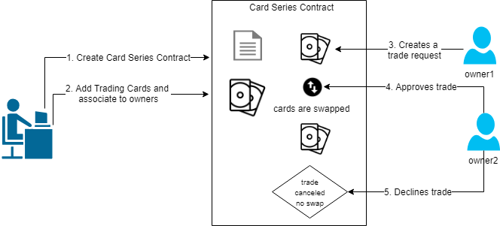

## POC Limitations

The current Card Trader POC doesn’t support multiple card trades, only one to one card trades are possible. The POC doesn’t support trades across Card Series, so all trading is done within and for the cards stored in a particular Card Series. The POC only has 6 card images so testers of the POC should only create card id’s 1 thru 6, these card id’s will then map to the test trading card images 1.jpg, 2.jpg, etc.

## Design and Requirements:

The Card Trader application is a browser-based client-side application written with React.js and Next.js frameworks and written using the JavaScript language. The Card Trader contracts and blockchain is hosted on the Rinkeby Test Network. All the functionality of the application that utilized an Ethereum blockchain rely on the MetaMask provider. The Card Trader applications requires the latest version of the Chrome browser and the latest version of the MetaMask Chrome Plug-In to work. In order to use the application, you must be logged into your MetaMask wallet. Also the CardTrader application is deployed to a Digital Ocean droplet and to load the client in your browser you will need to go to the following url.

***URL to Use in the Chrome Browser to Load the Card Trader Application in the Chrome browser:***

[**http://104.248.238.170:3000**](http://104.248.238.170:3000)

## The Application

The CardTrader application has a very simply UI that has a landing page that has two Navigation buttons, Manage and Card App.

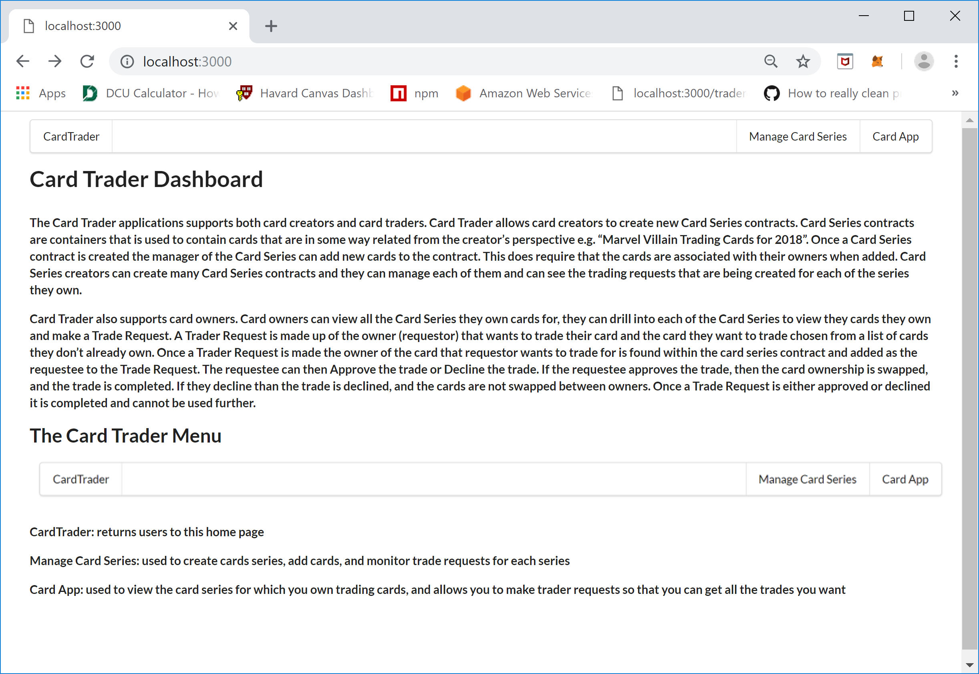

The menu items at the top the Card Trader Dashboard is as follows:



The “Card Trader” menu item brings you back the homepage, the “Manage Card Series” item allows card creators to create new Card Series contracts, provision trading cards, and monitor trading requests for a specific card series. The “Card App” menu item allows card owners to see the Card Series contracts for which they have Trading Cards for and to create Trade Request. When you click either “Manage Card Series” or “Card App” will request you to login to MetaMask if the user is not already logged in.

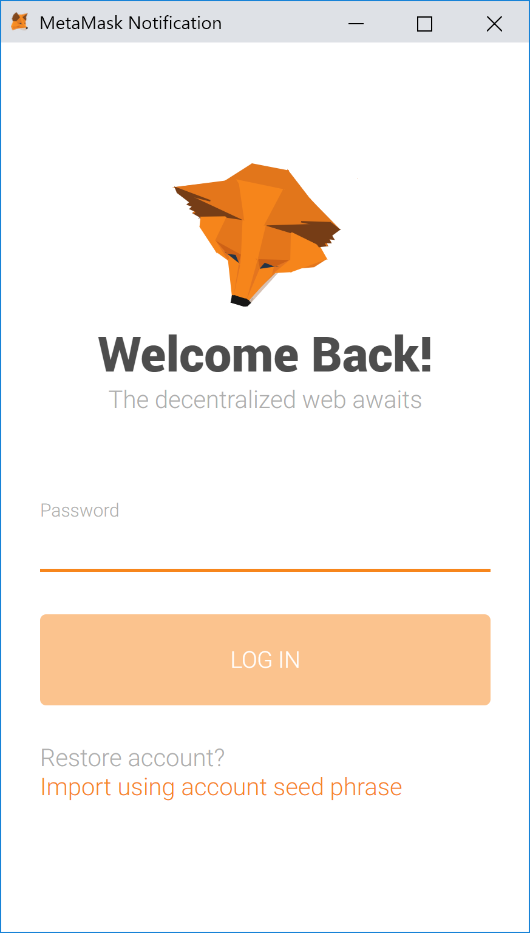

Also, clicking either choice will bring up a MetaMask wallet request to allow the Card Trader application to connect to it. If you see this message, please click the Connect button so that the application can interact with the MetaMask wallet.

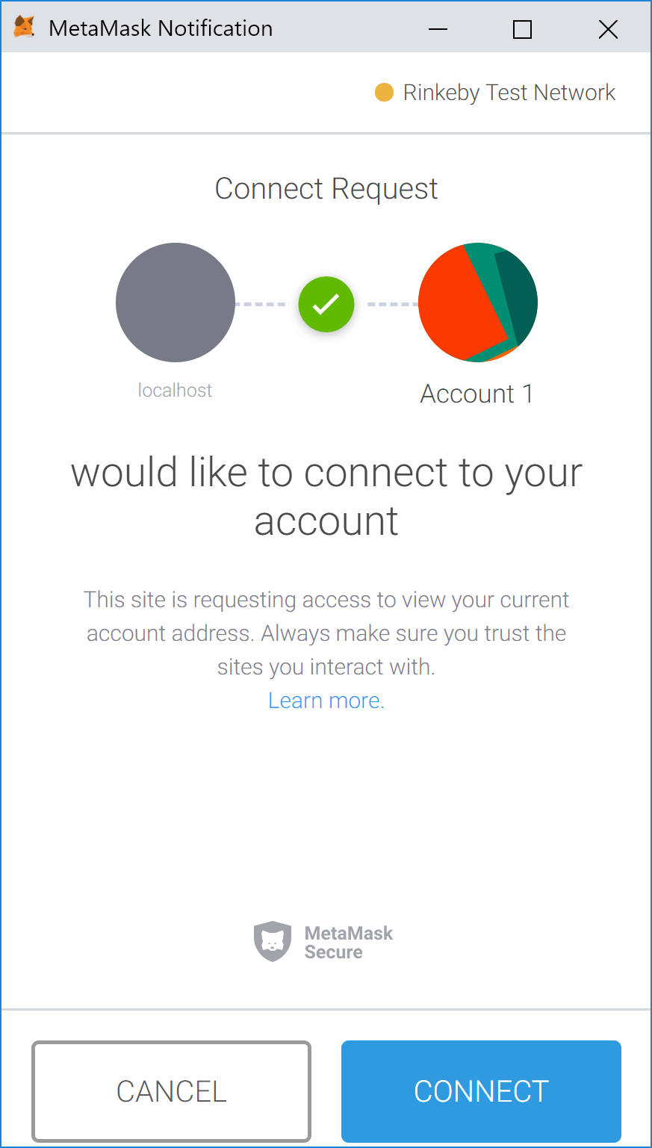

### Manage Card Series

Once you are logged into your MetaMask wallet and you have allowed the Card Trader application to connect to the MetaMask wallet you will see the following screen if you haven’t created any Card Series yet.

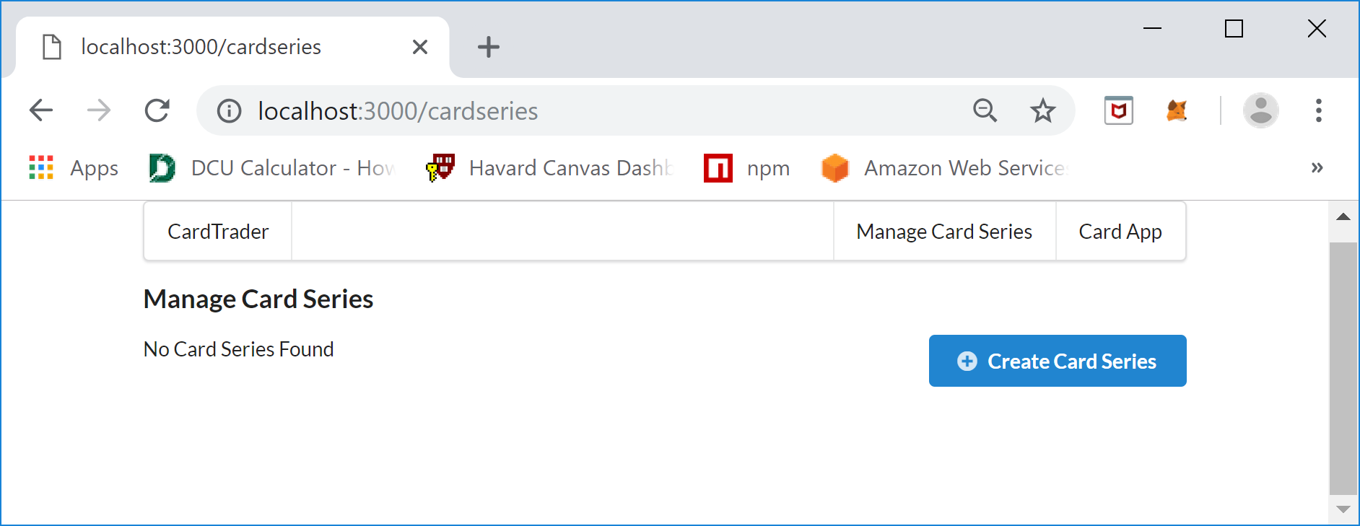

The first thing you want to do as a Trading Card creator is to create a Card Series to hold all the Trading Cards you are issuing. To achieve this, click the “Create Card Series” button an you will see the following Card Series form screen:

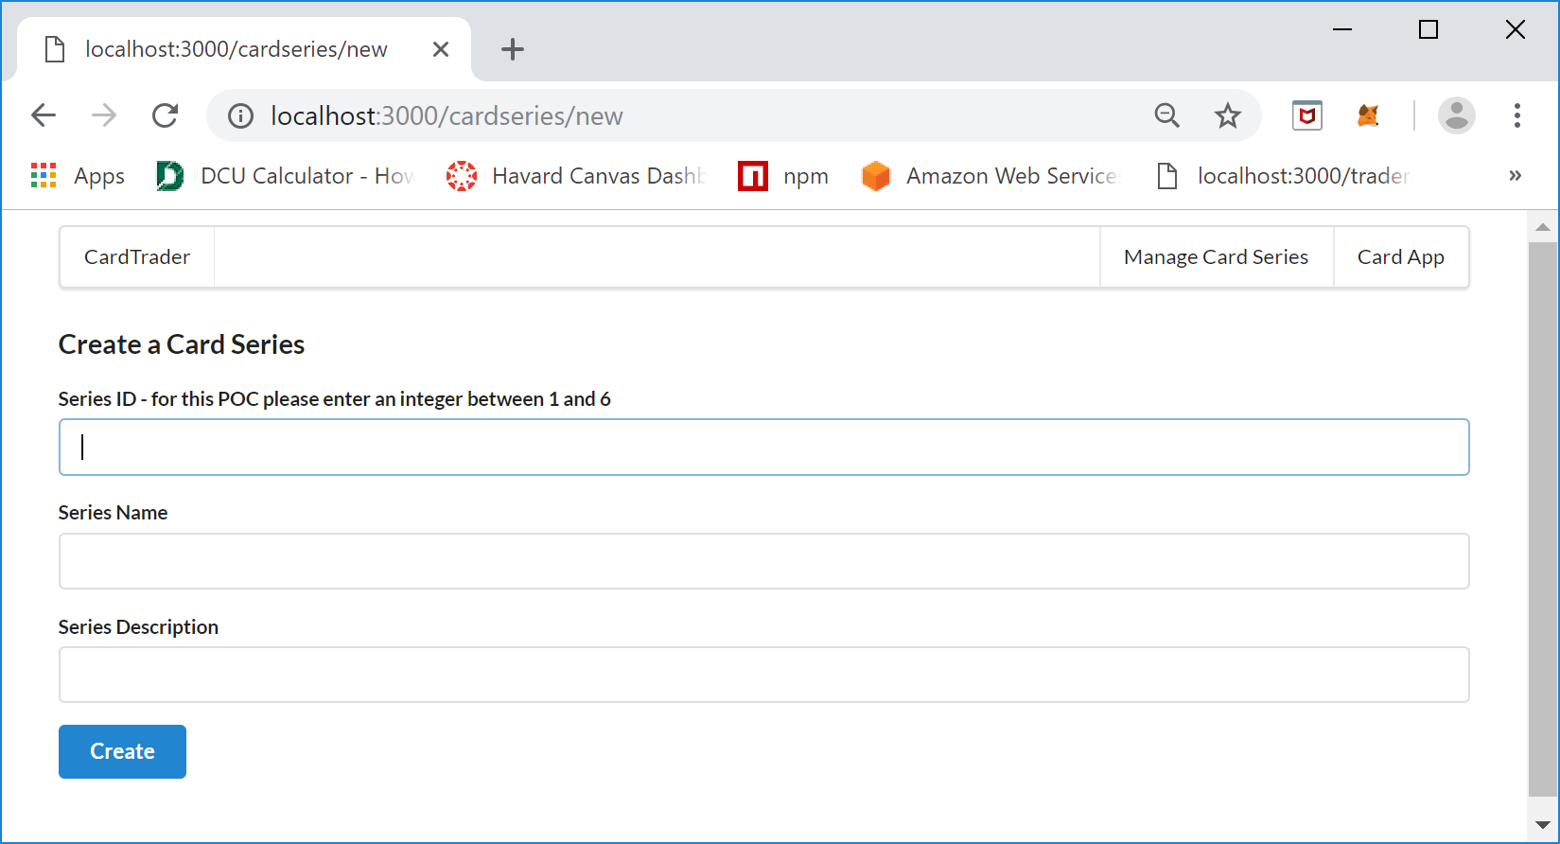

On this screen creators create a Card Series by entering a Card Series ID, Series Name, and Series Description. The Series ID must be an integer value that will be used as a key to retrieve the details of the Card Series after it is created, the Series Name is a friendly name that you wish to display to the user, and the Series Description is a detailed description of the Card Series that describes the type of Trading Cards the Card Series contains. An example of a valid entry is as follows:

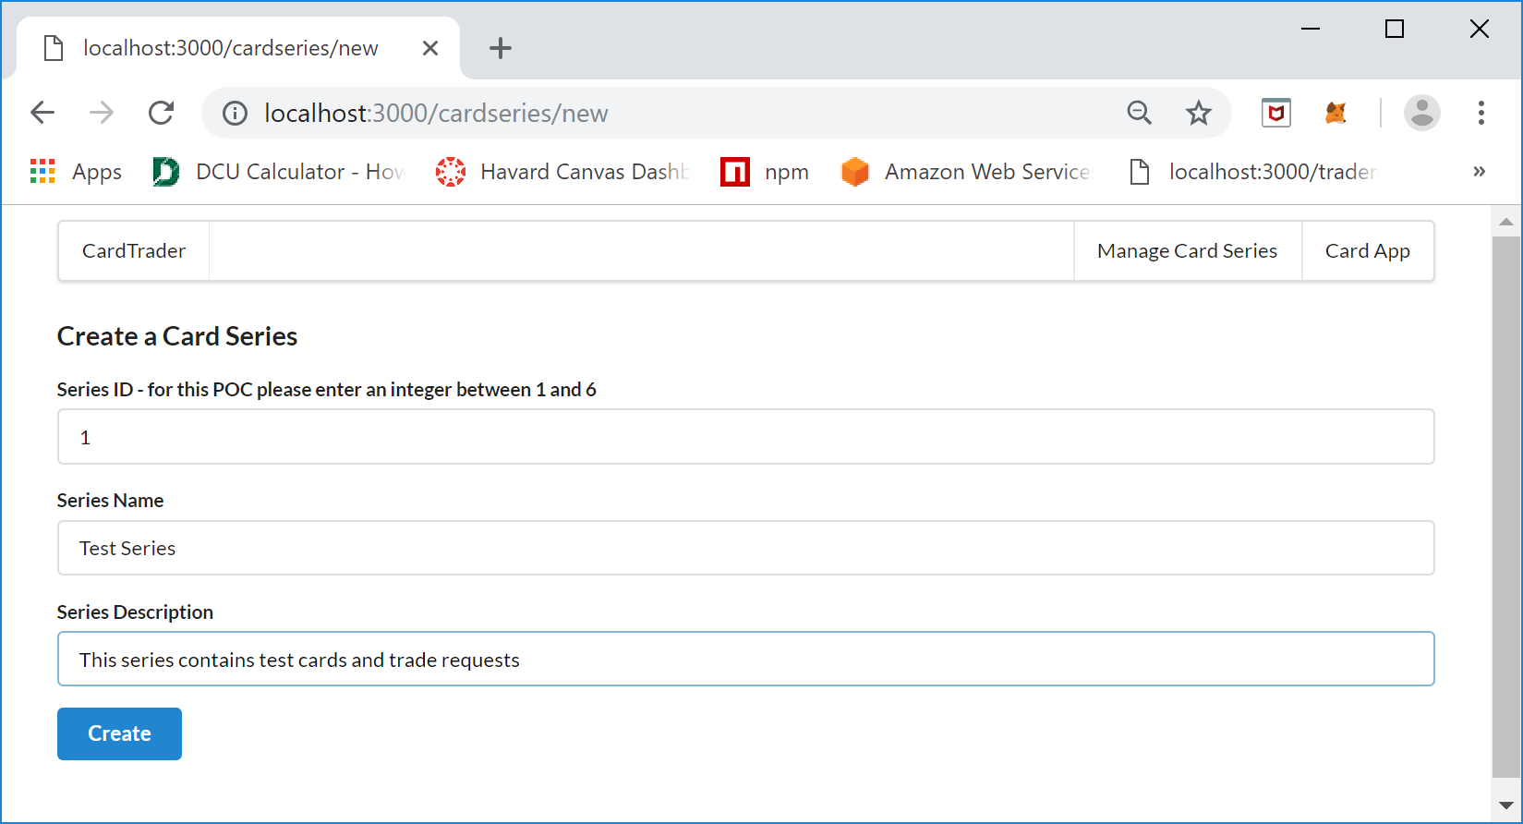

Click the “Create” button to create the Card Series. Once you click the Create button you will see the following MetaMask screen confirming that you want to process the request to the blockchain and pay the gas charges:

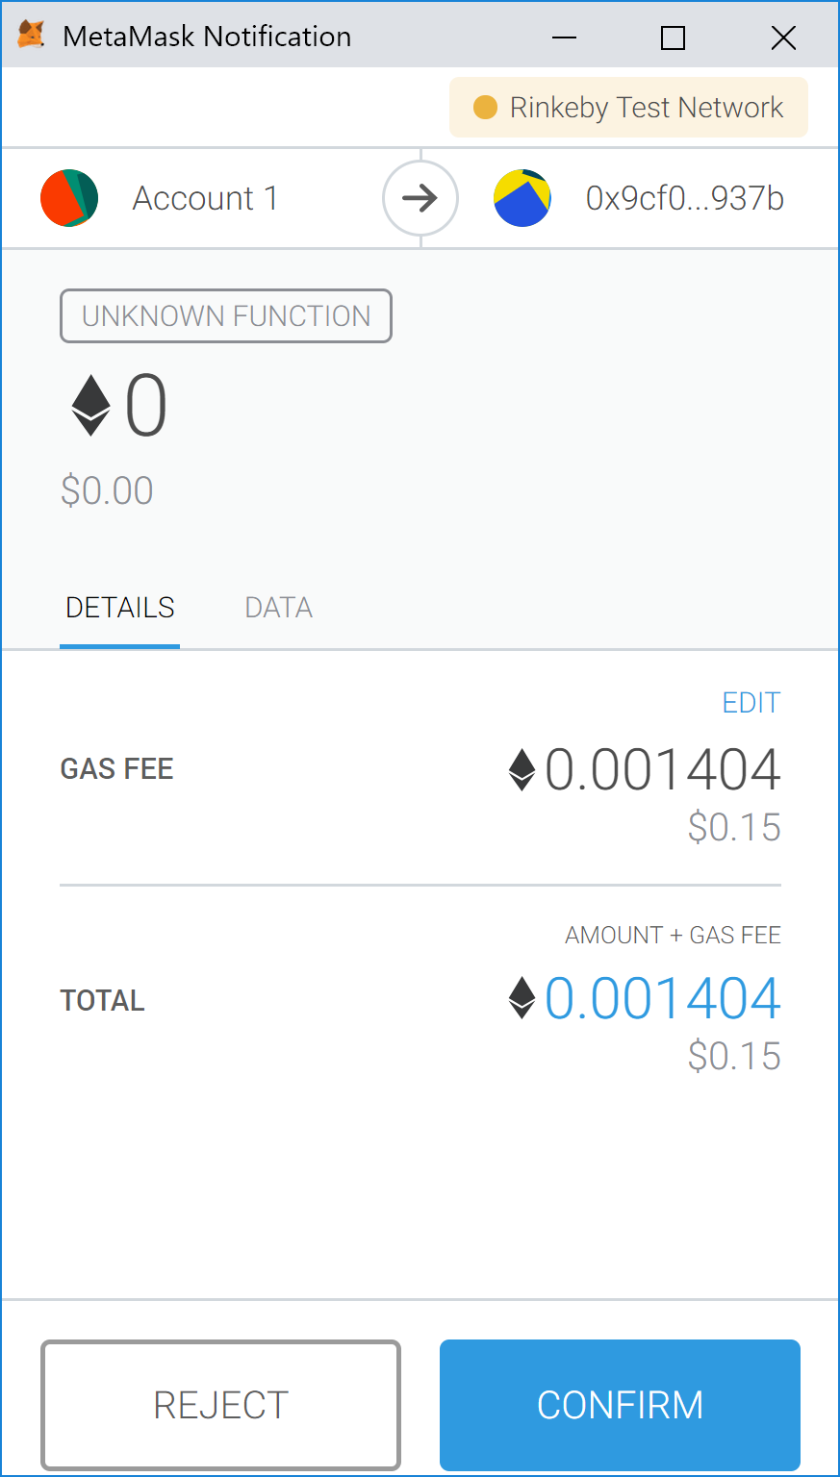

Click “Confirm” to continue to create the Card Series. Once the processing of the request is complete you will be brought back to the “Manage Card Series” screen and the new Card Series should be listed, if it isn’t please click the browser Reload button, occasionally the screen doesn’t refresh properly.

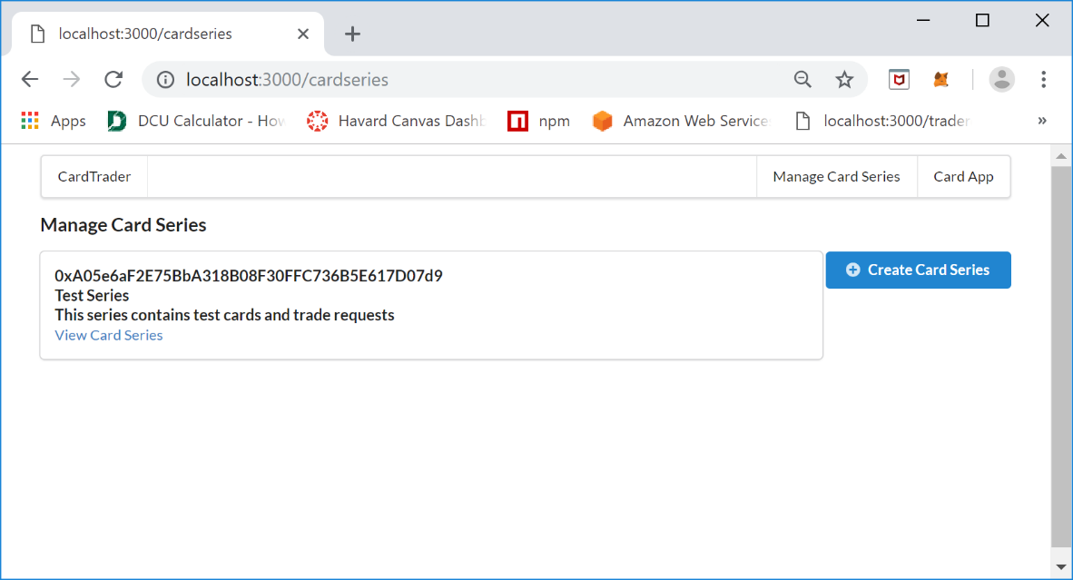

The “Manage Card Series” screen shows a list of the Card Series that have been created by the owner associated with the MetaMask address used to create the series. The list shows the Card Series address and a link “View Card Series” that allows you to see a summary of the Card Series, View Trade Requests, and add Trading Cards. The next step is to add Cards to the Cards Series. To do this a creator clicks the “View Card Series” link and you will see the following screen:

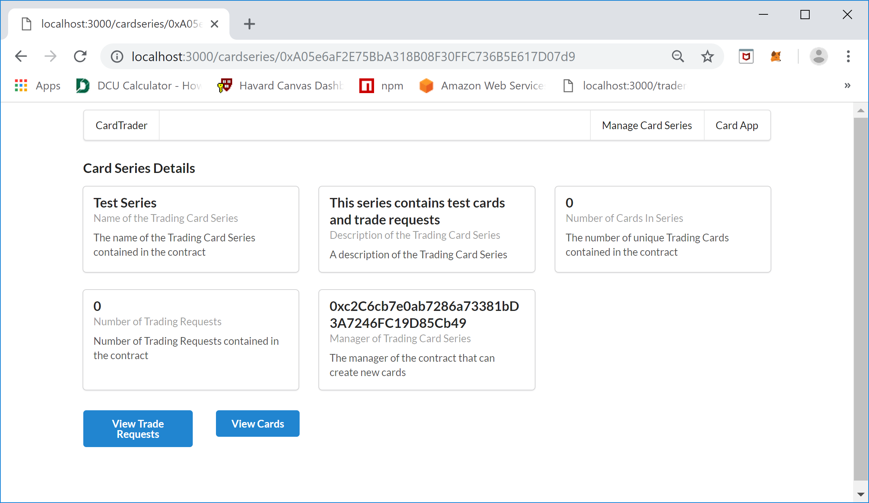

The “Card Series Details” screen allows you to see the Card Series contract details as well as to view the Trade Requests and Cards that are contained within the Card Series Contract. The next step for a creator is to add new cards to the Card Series Contract, to accomplish this click the “View Cards” button and you will see the following screen:

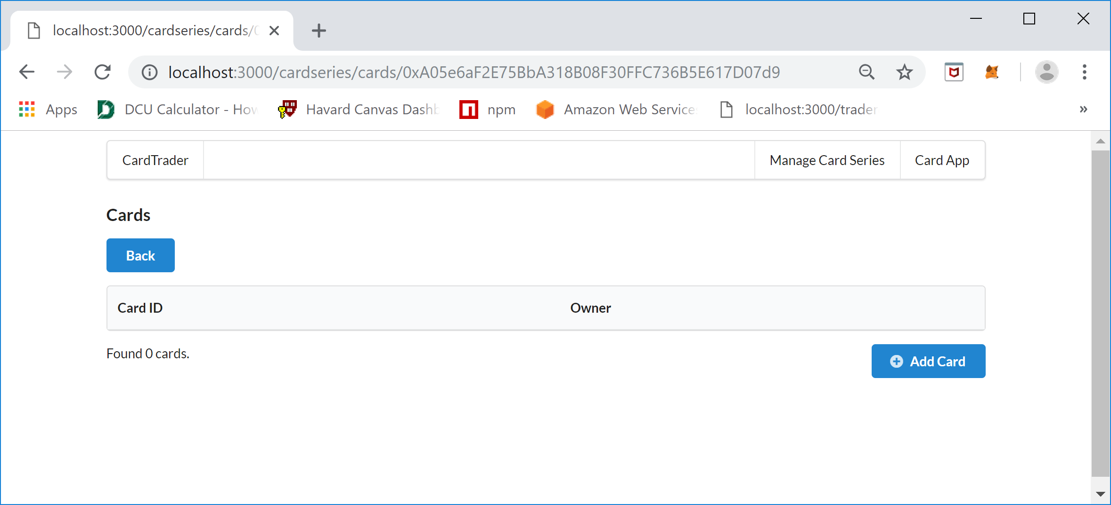

Since this is a newly created Card Series there are no cards contained within it yet. To create a new Card, click the “Add Card” button and you will see the following screen:

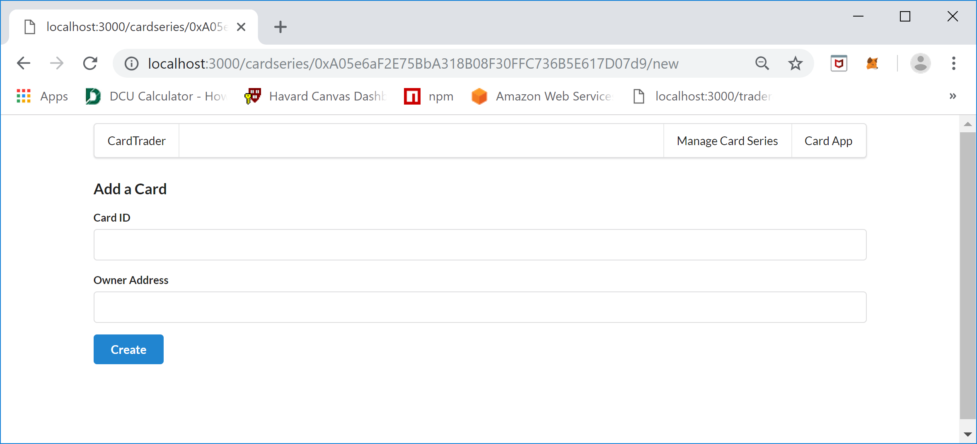

The “Add a Card” screen requires a Card ID that is unique within the Card Series and the Owner Address. The Card ID is an integer value and the Owner Address is the wallet address of the card owner not the creator but the owner of the card. For this proof of concept application, the creator should only create up to six cards and should use the card id’s 1 thru 6, also for the proof of concept the owner oft the cards can also be the manager. For testing you will want to use two different MetaMask account addresses to represent two different users that can trade cards between each other, but you must add the cards as the Manager which is the MetaMask wallet address that created the Card Series. The following is an example of adding a card:

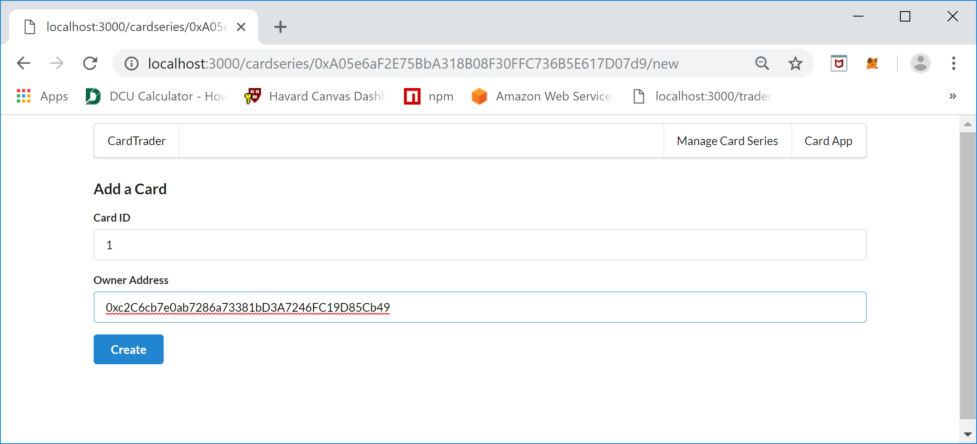

Once the Create button is clicked you will again see a MetaMas Notification screen asking to REJECT or CONFIRM the transaction, to proceed click the CONFIRM button. Once the transaction is processed the following screen will be displayed listing all the Cards created so far in the series.

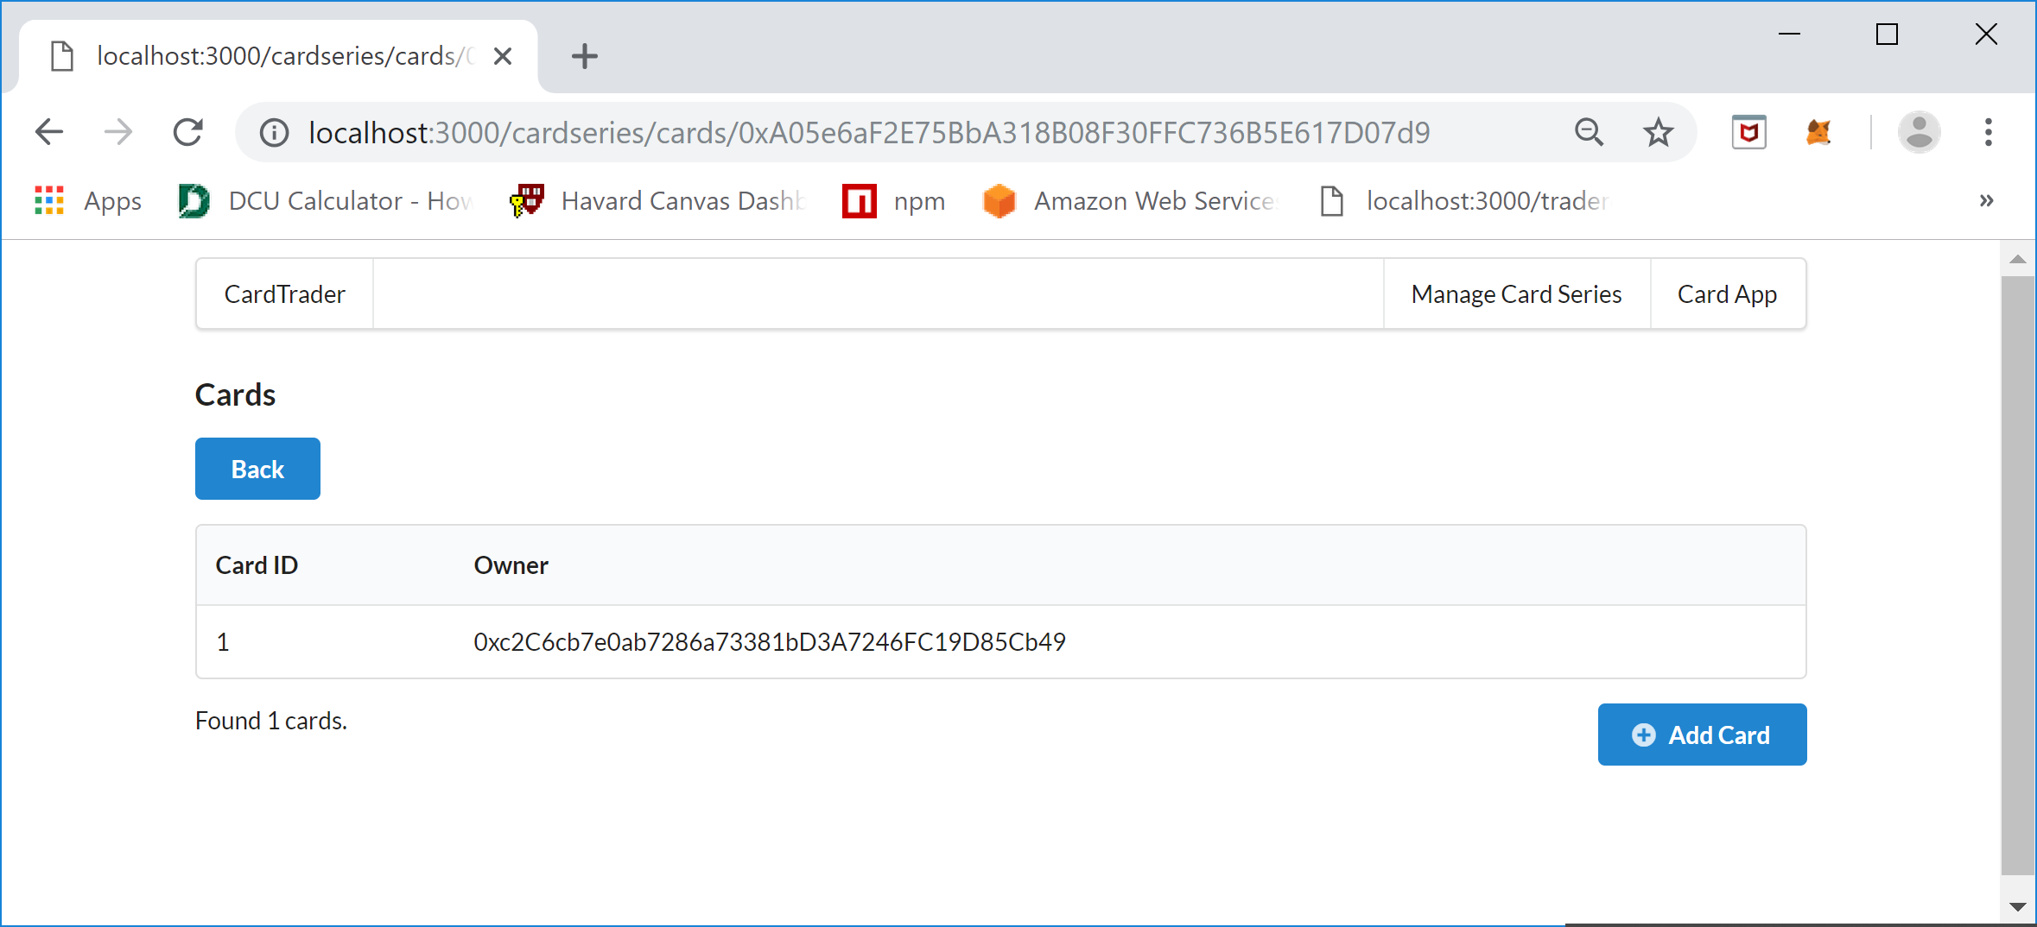

The manger of the Card Series will than add all the Cards they want to the Card Series. For demonstration purposes the following cards were added.

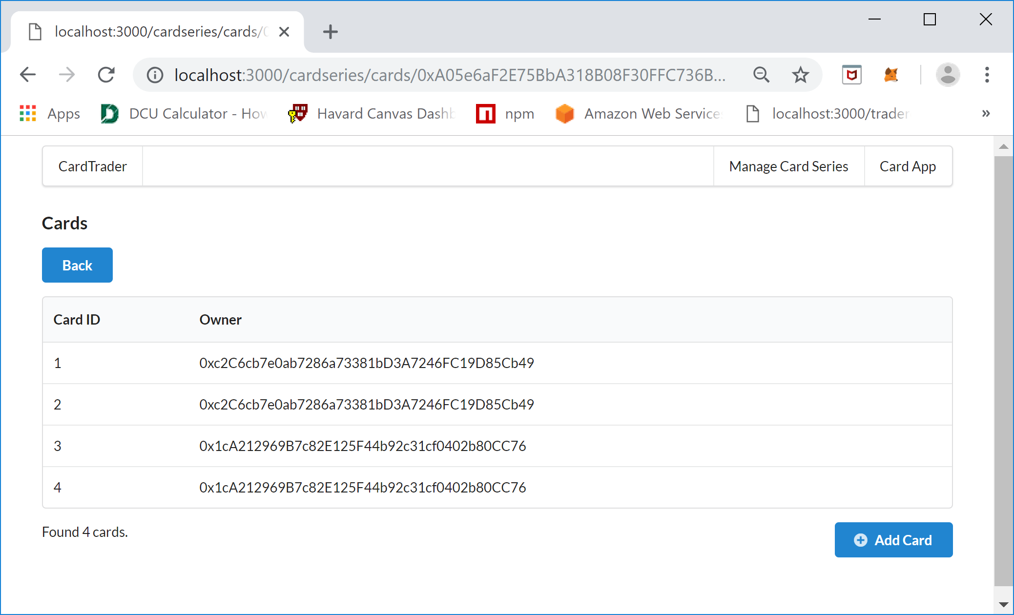

The next step is to check the Card Series Details to see a summary of what has been done so far, to do this click the back button and you will again see the Card Series Details screen:

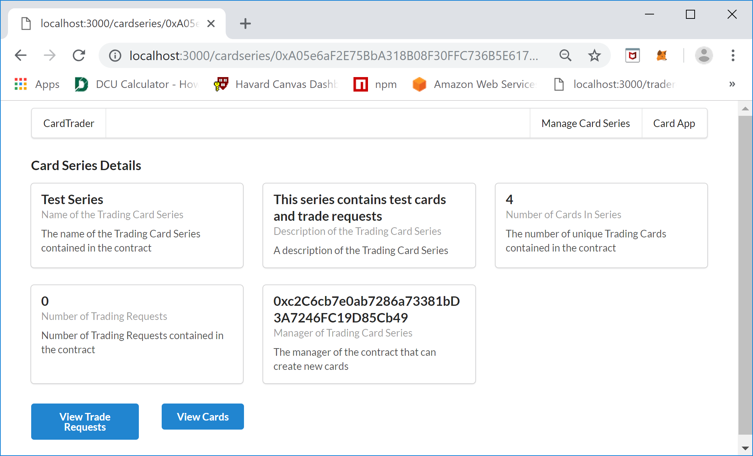

After adding the cards for the Card Series, the Card Series Detail screen will have the number of cards changed to reflect the number of Trading Cards added to the Card Series Contract. The next step is to switch over to the Card owner view of the contract by clicking the “Card App” menu item in the upper right of the screen.

### Card App (Card Owner/Trader Application)

Once the “Card App” menu item is clicked at the top right using a MetaMask account address that you have assigned Trading Cards to a Card Series you will see the following screen:

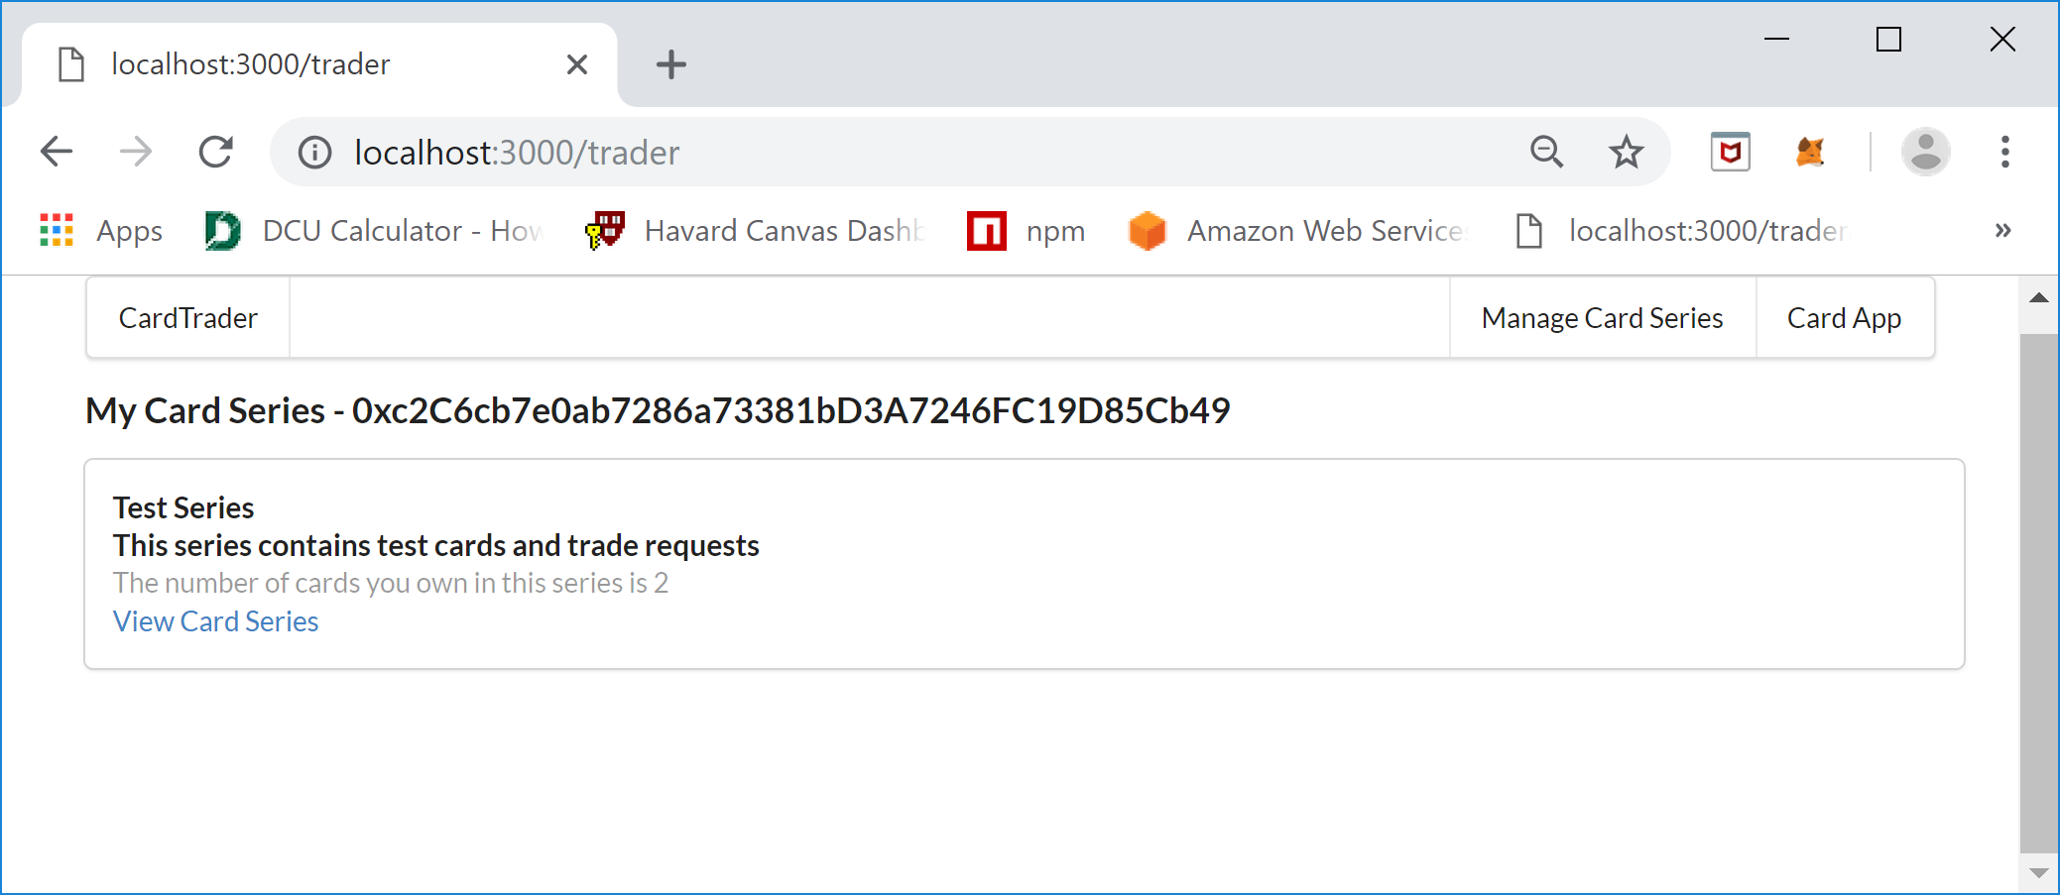

The “My Card Series” screen shows the Card Series where there are Trading Cards assigned to the currently selected MetaMask Wallet Account Address. The number after the “My Card Series – “ is the current MetaMask Wallet Account Address. For each Card Series you will see the Series Name, Series Description, the number of cards you own and a link to view the cards. Click the “View Cards Series” link to see the Trading Cards associated with the account and the following will be display:

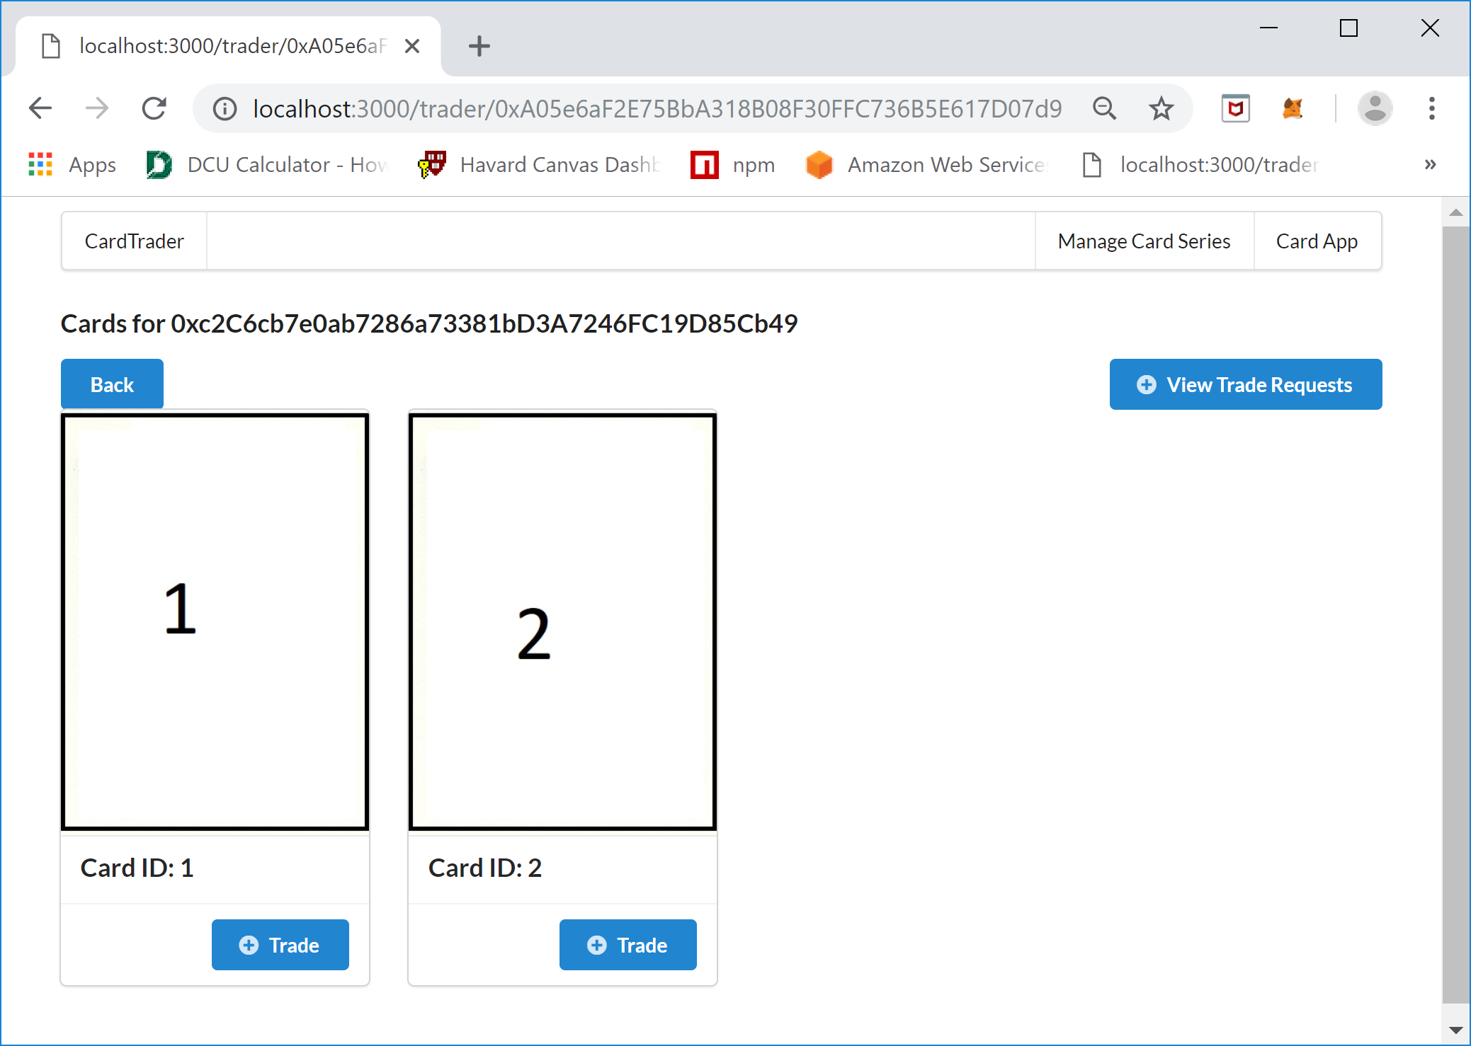

This Cards screen shows the cards for the currently selected MetaMask Wallet Account address. The number after the “Card for “ is the Wallet Account Address that is being used to retrieve the Trading Cards that are owned by the account. From this screen you can view the trade requests that are associated with the selected account and a Card can be selected to create a Trader Request to trade a card. For example, to Trade the 1 Card with Card ID 1 the Trade button is clicked under the card. Once the Trade button is clicked the following screen will be displayed:

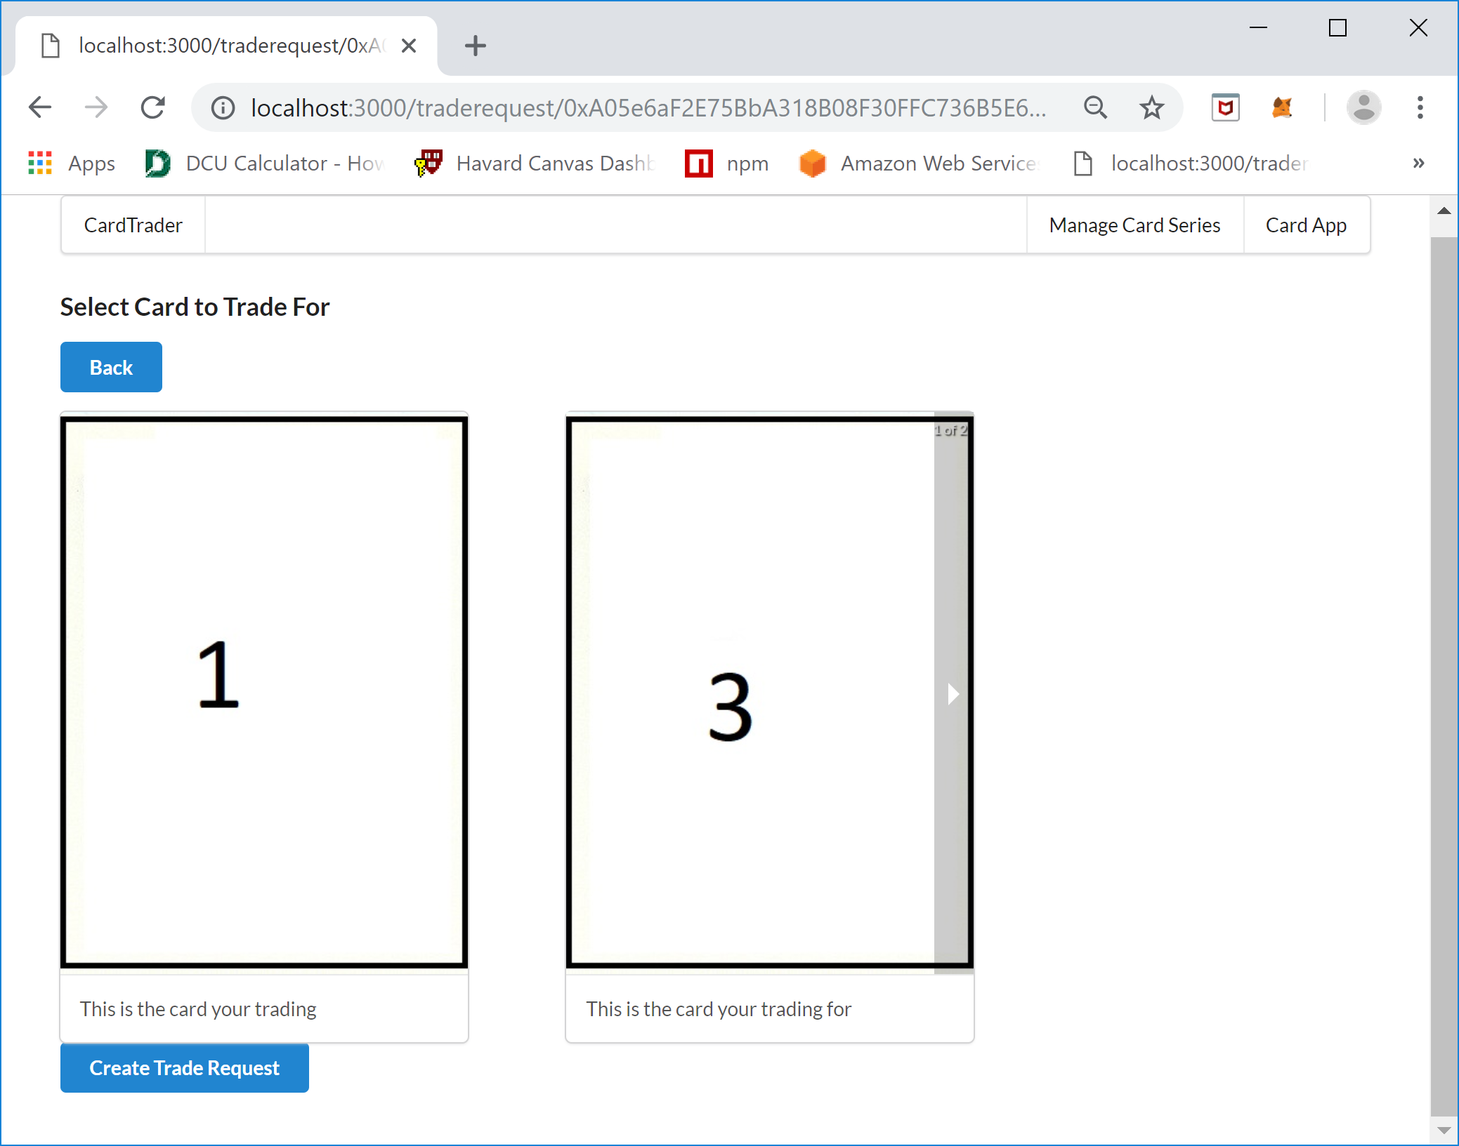

On the “Select Card to Trade For” screen you will see the card that is already owned by the account on the left and the card to trade for that isn’t owned by the current account on the right. Notice that there is an arrow bar on the edge of the card to trade for, the cards to select are loaded in a carousel control and you can iterate over the cards by hovering over the right or left edge of the card and clicking he arrow bar.

Here is a more detailed view of how the carousel control works:

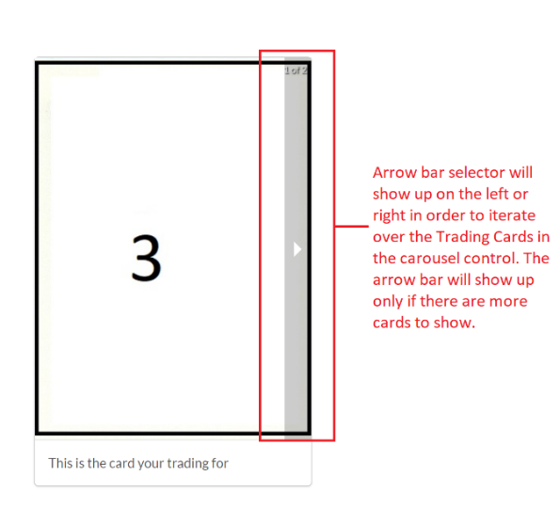

It is important to note that the arrow bar will show on the right to move forward through the list of cards and on the left when going back through cards. Once the desired Trading Card is found to trade for the owner then clicks the “Create Trade Request” button at the bottom left of the screen to make a Trade Request. A MetaMask Notification screen will display click CONFIRM to continue and create the Trading Request, the following screen should be seen when complete:

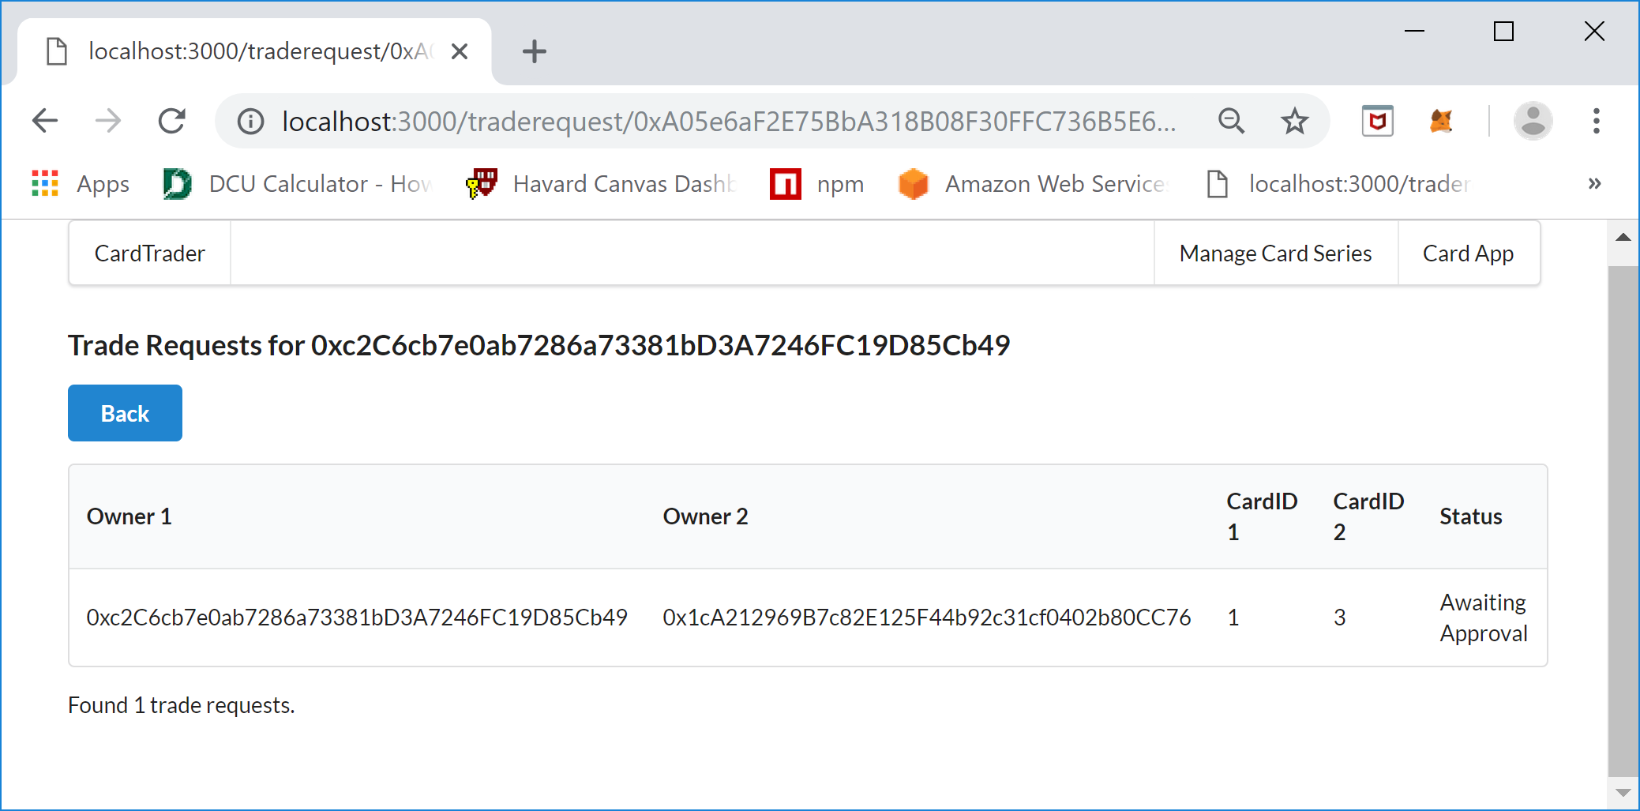

This is the Trade Requests screen, the number after the test “Trade Requests for “ is the current MetaMask Account. On this screen there will be a list of Trade Requests made by the current account and will show Owner1, Owner2, CardID 1, CardID 2, and Status of the Trade Request. Owner1 is the owner of the card that is making the Trader Request and will be called the requestor, CardID 1 is the card that the requestors card that they want to trade, Owner 2 is the owner of the card the requestor wants to trade for and CardID 2 is the card that the requestor wants to obtain and is called the Requestee. The Status is the stage or state of the Trade Request. The requestor submits the Trade Request but the owner of the card the requestor wants to trade for is the approver of the Trade Request and can either Approve or Decline the request. In order to see the Requestee’s view you will need to switch the currently selected MetaMask account to the Requestee’s account and refresh the screen or click the Card App menu item and navigate to View Trade Requests. Here are the steps, first select the Requestee account in MetaMask:

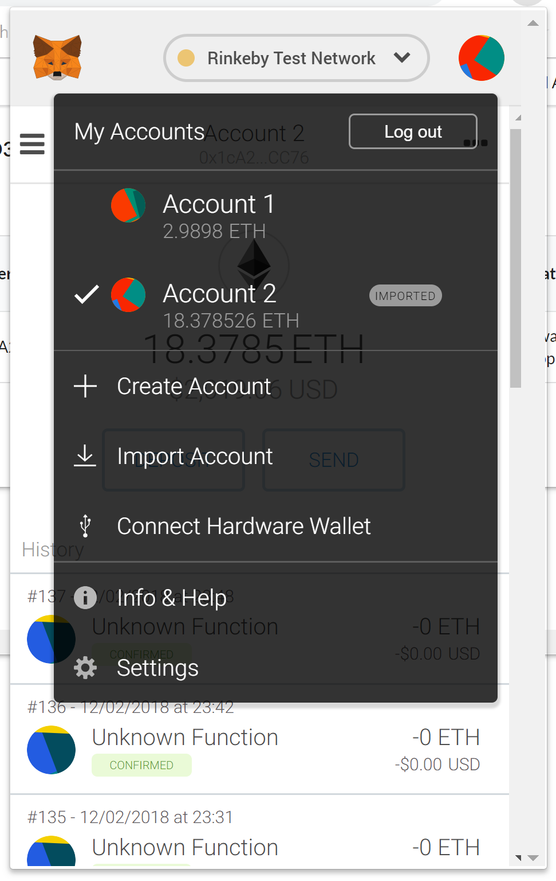

The refresh the “Trade Requests” screen and you should see the following screen:

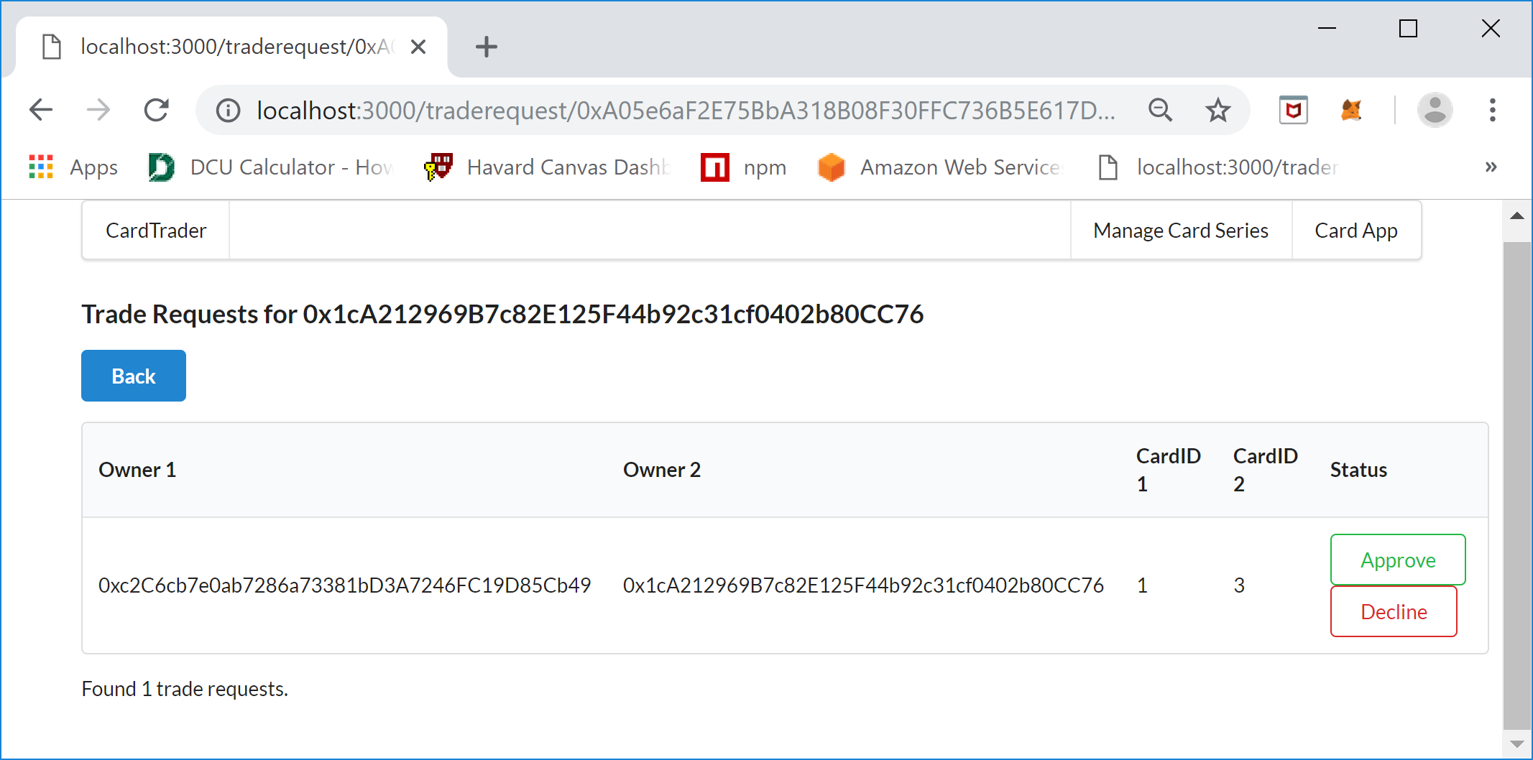

The Requestee’s view of the screen shows that the owner of the card that Request (owner1) wants to trade for shows an Approve and Decline button. If the Requestee (owner2) Declines the Trade Request than the status of the TradeRequest changes to Declined and the workflow for the trade ends. If the Requestee Approves the request then the Trade Request is carried out , the ownership of the cards is swapped and the Trade Request status changes to Completed. For example the Approve button will be clicked, MetaMask will ask to CONFIRM the request and pay the gas and the transaction will be attempted. The Trade Request screen should refresh, sometimes this fails and requires a manual refresh, and the status of the Trade Request will be updated to Completed, the following should be displayed:

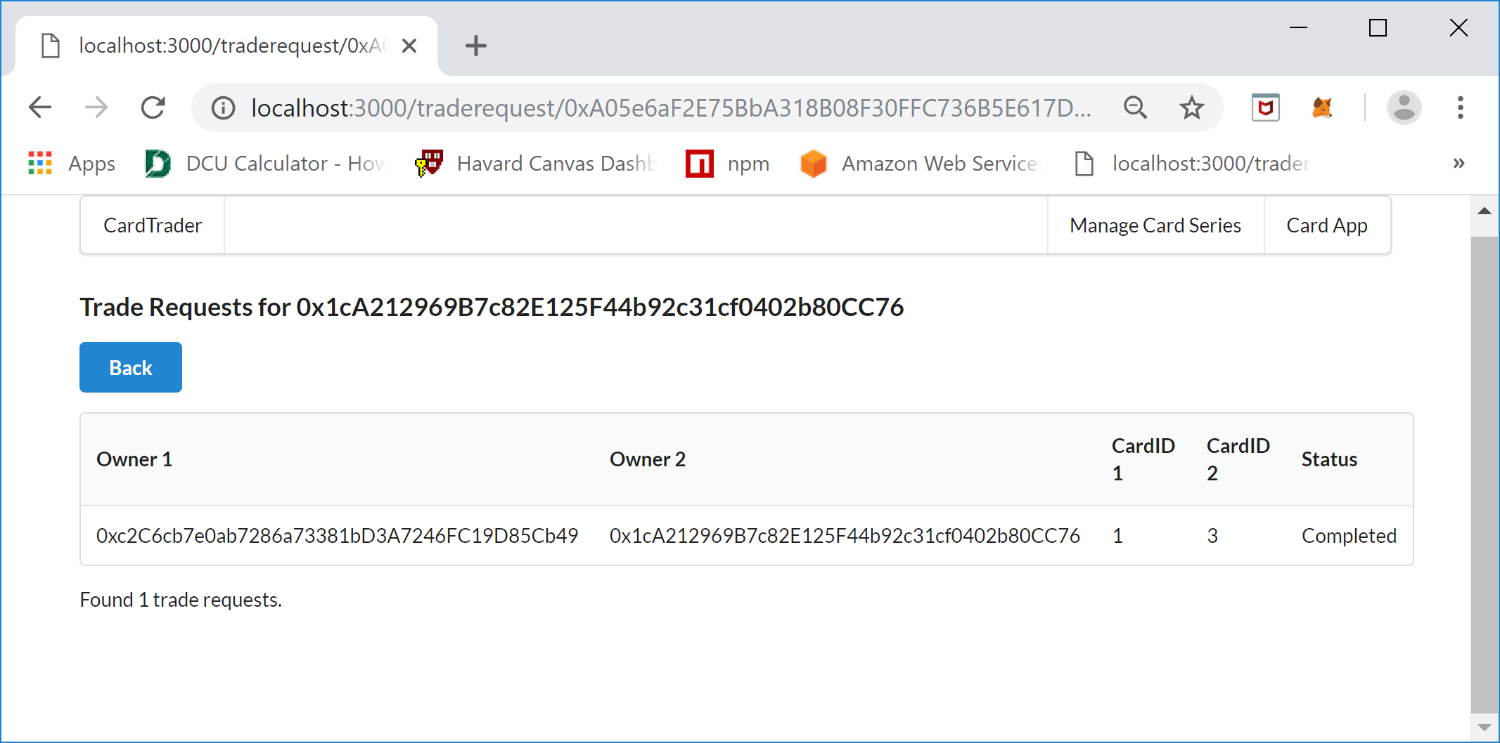

If the Trade Request worked then the cards owned by the Requestee will go from Card ID 3, and 4 to Card ID 1, and 4. To view this click the Back button to go back to the Cards screen:

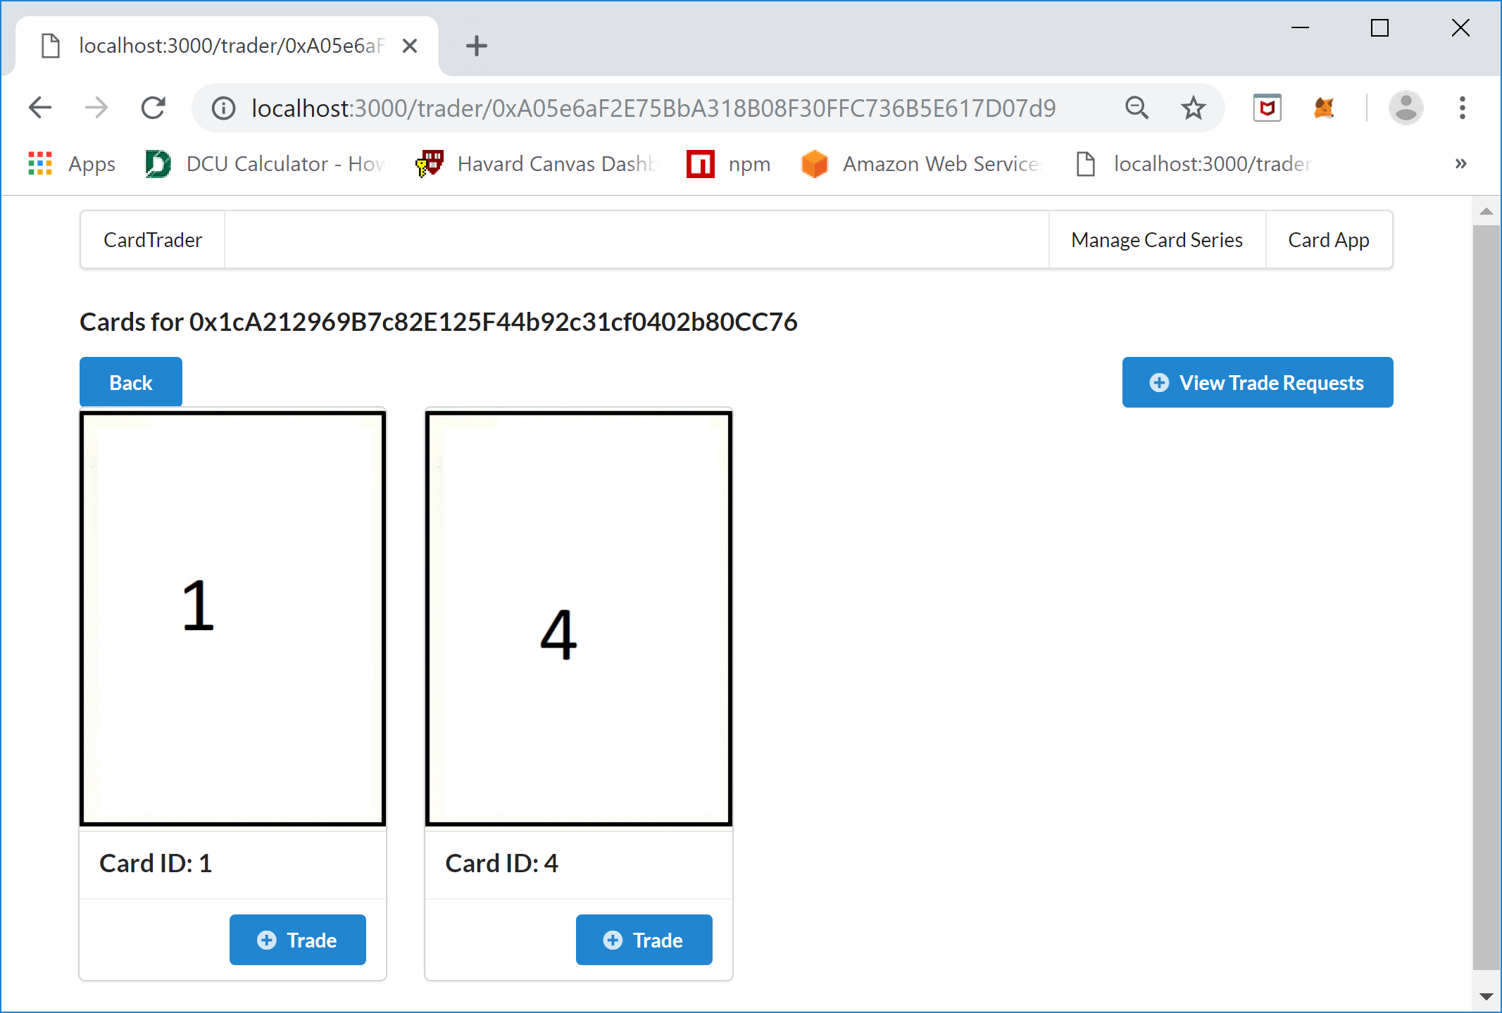

And the Requestor (owner1) should now own cards with Card ID’s 2, and 3. To prove this switch the MetaMask account back to the Requestor and then refresh the screen:

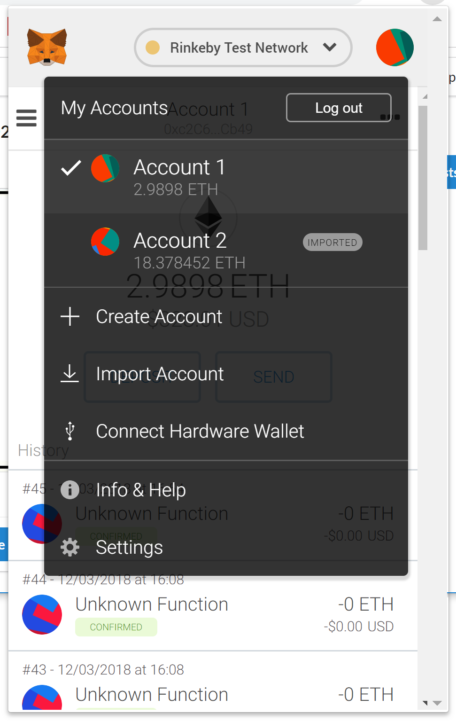

Then refresh the screen and the following should be displayed:

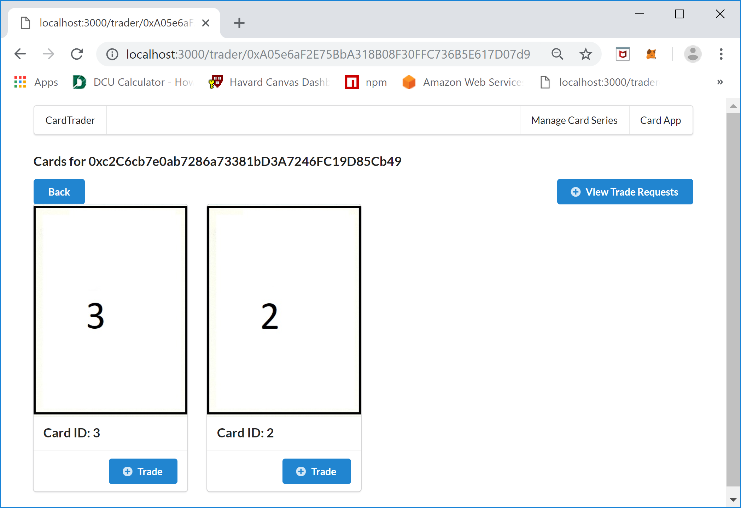

The Cards screen for the Requestor (owner1) is correct and the Trade Request was carried out.

### Extra - Contract Verification:

To check that the contract has the correct values after the swap we can use the Card Series Contract address to view the Trade Request through remix. To get the Card Series Address just click on the “Manage Card Series” menu item at the top right of the screen:

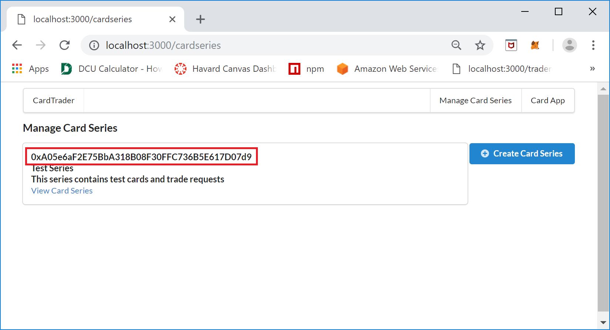

You will also need the solidity code to put into Remix and compile it so that you can check the already deployed contract using the address above on the Rinkeby Test Network. Go to the Run tab choose the CardSeries contract from the pulldown list, enter the above contract address in the At Address text box and click the “At Address” button. Then in the “Deployed Contract” section click the GetAllTradeRequests button and copy the resulting Trade Request Key. Put the key in the tradeRequestsBy accessor and click the tradeRequestsByKey button and you will see the completed Trade Request:

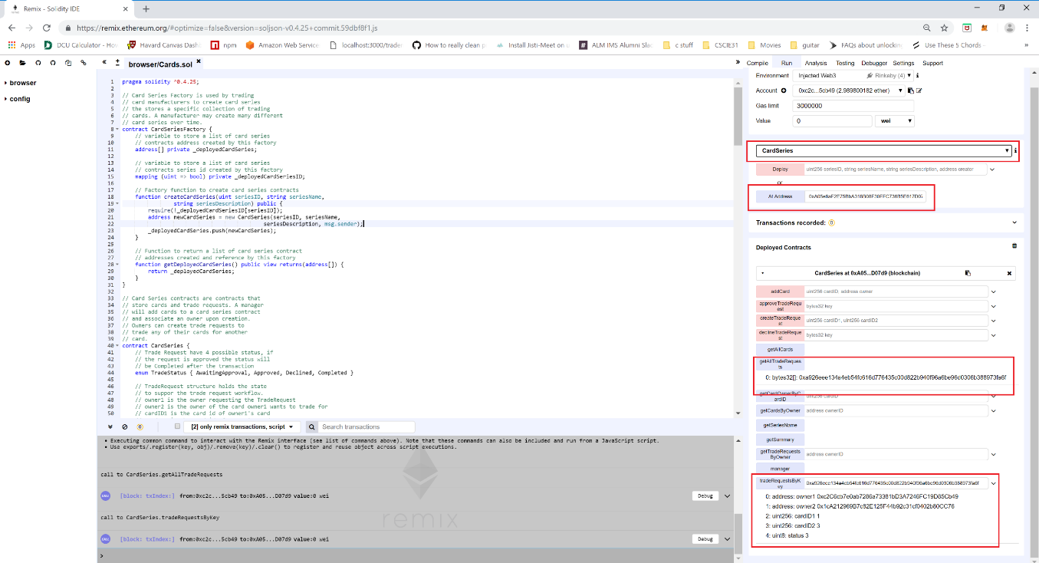

## The Code

The DApp was written using the Next.js JavaScript framework which in turn uses React.js. All DApp code is written in Javascript and the contract is written using the Solidity language using version 0.4.25. The UI is using a mixture of JSX and semantic-ui-react components.

The project files are as follows:

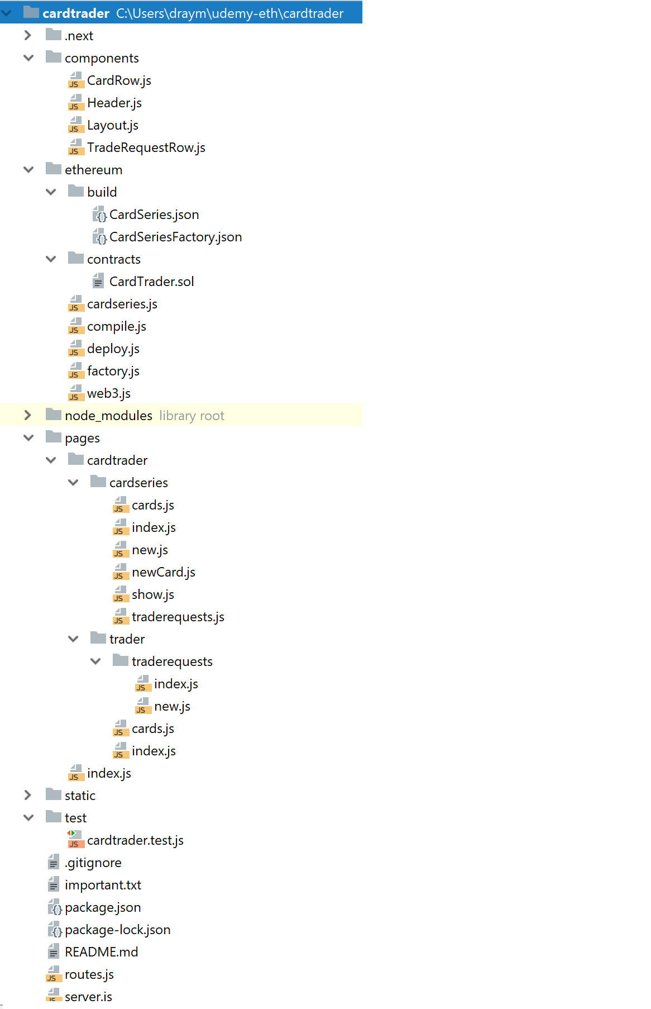

### The Pages

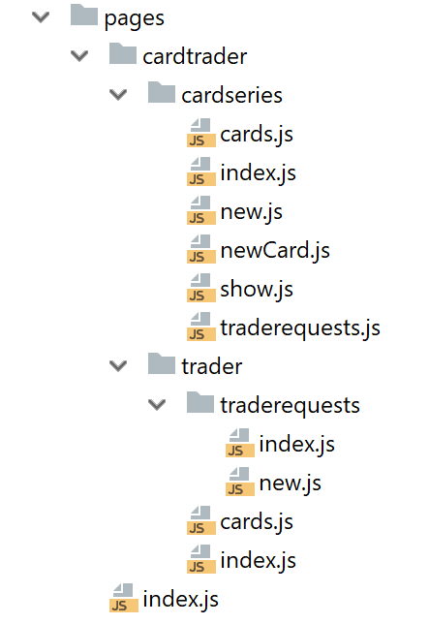

The pages directory has all the main pages within the CardTrader application.

The pages that are used for the “Manage Card Series” functionality is in the /cardtrader /cardseries directory.

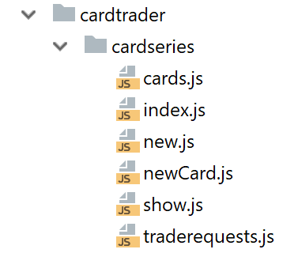

The following are the names of the pages and the rendered web pages they relate to:

/cardtrader/cardseries/index.js – Page which lists all the Card Series for the currently selected MetaMask Wallet Account

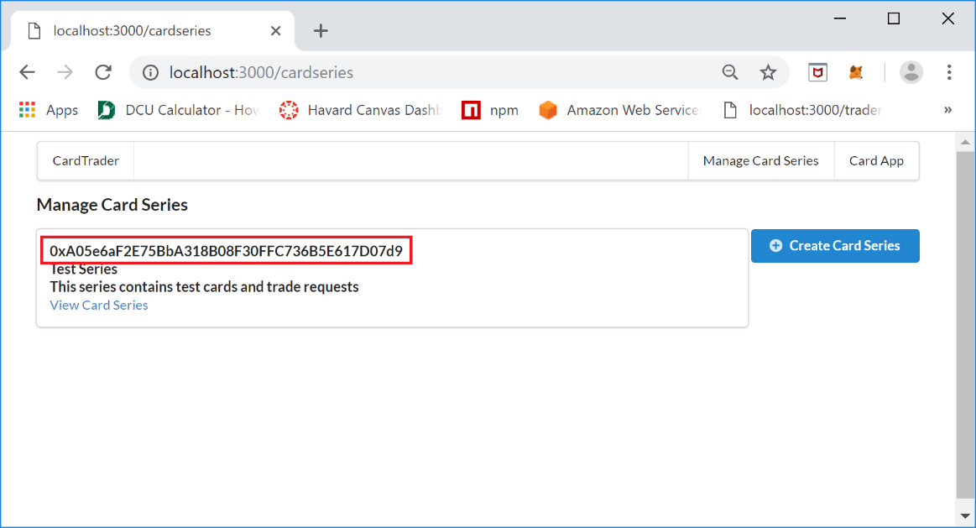

/cardtrader/cardseries/new.js – Page that creating a new Card Series

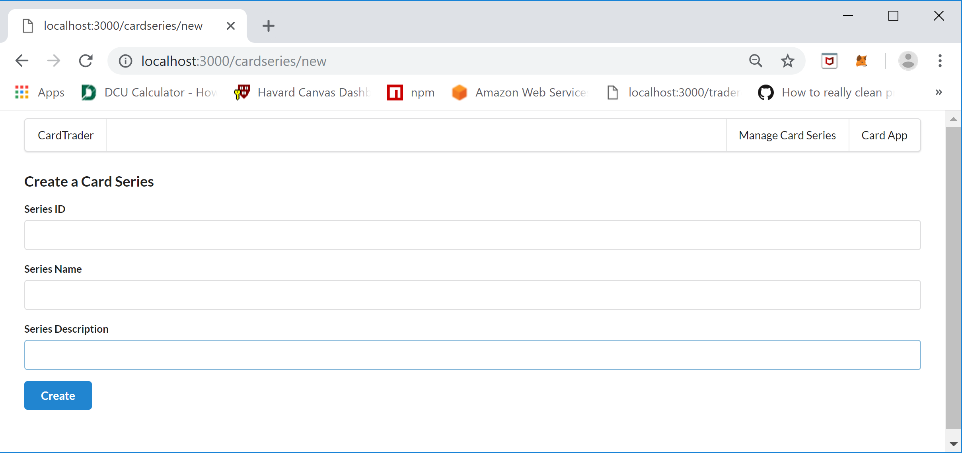

/cardtrader/cardseries/show.js – Page that shows the details for the selected Card Series

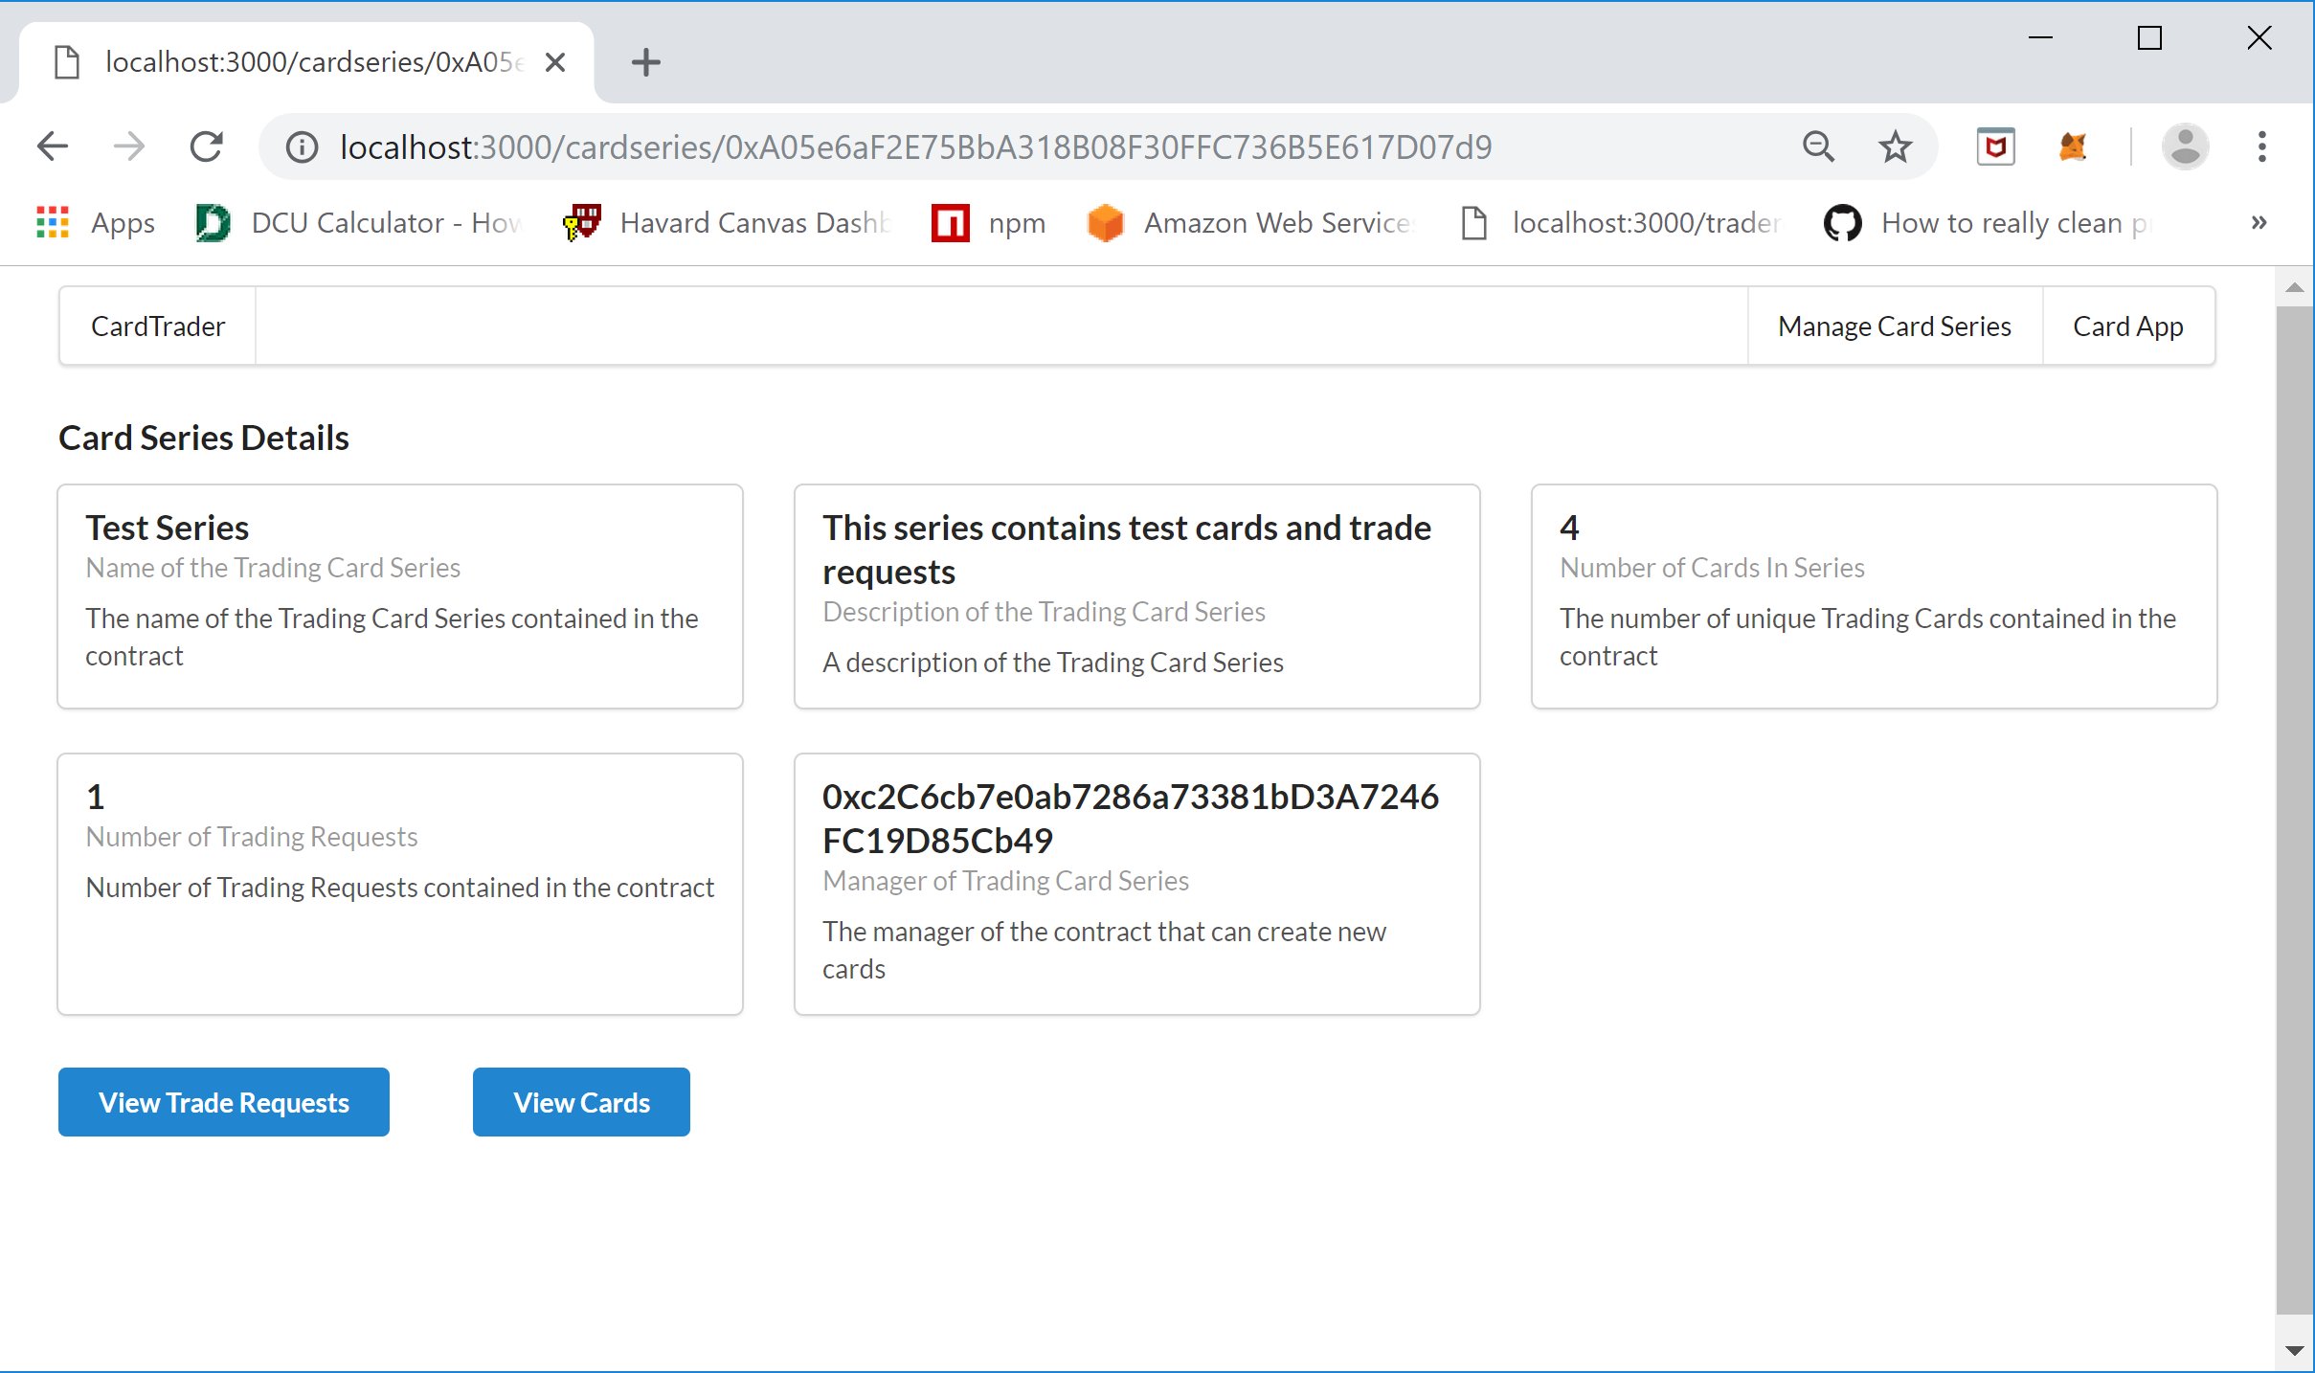

/cardtrader/cardseries/cards.js – Page that lists all the Trading Cards that have been provisioned for the selected Card Series

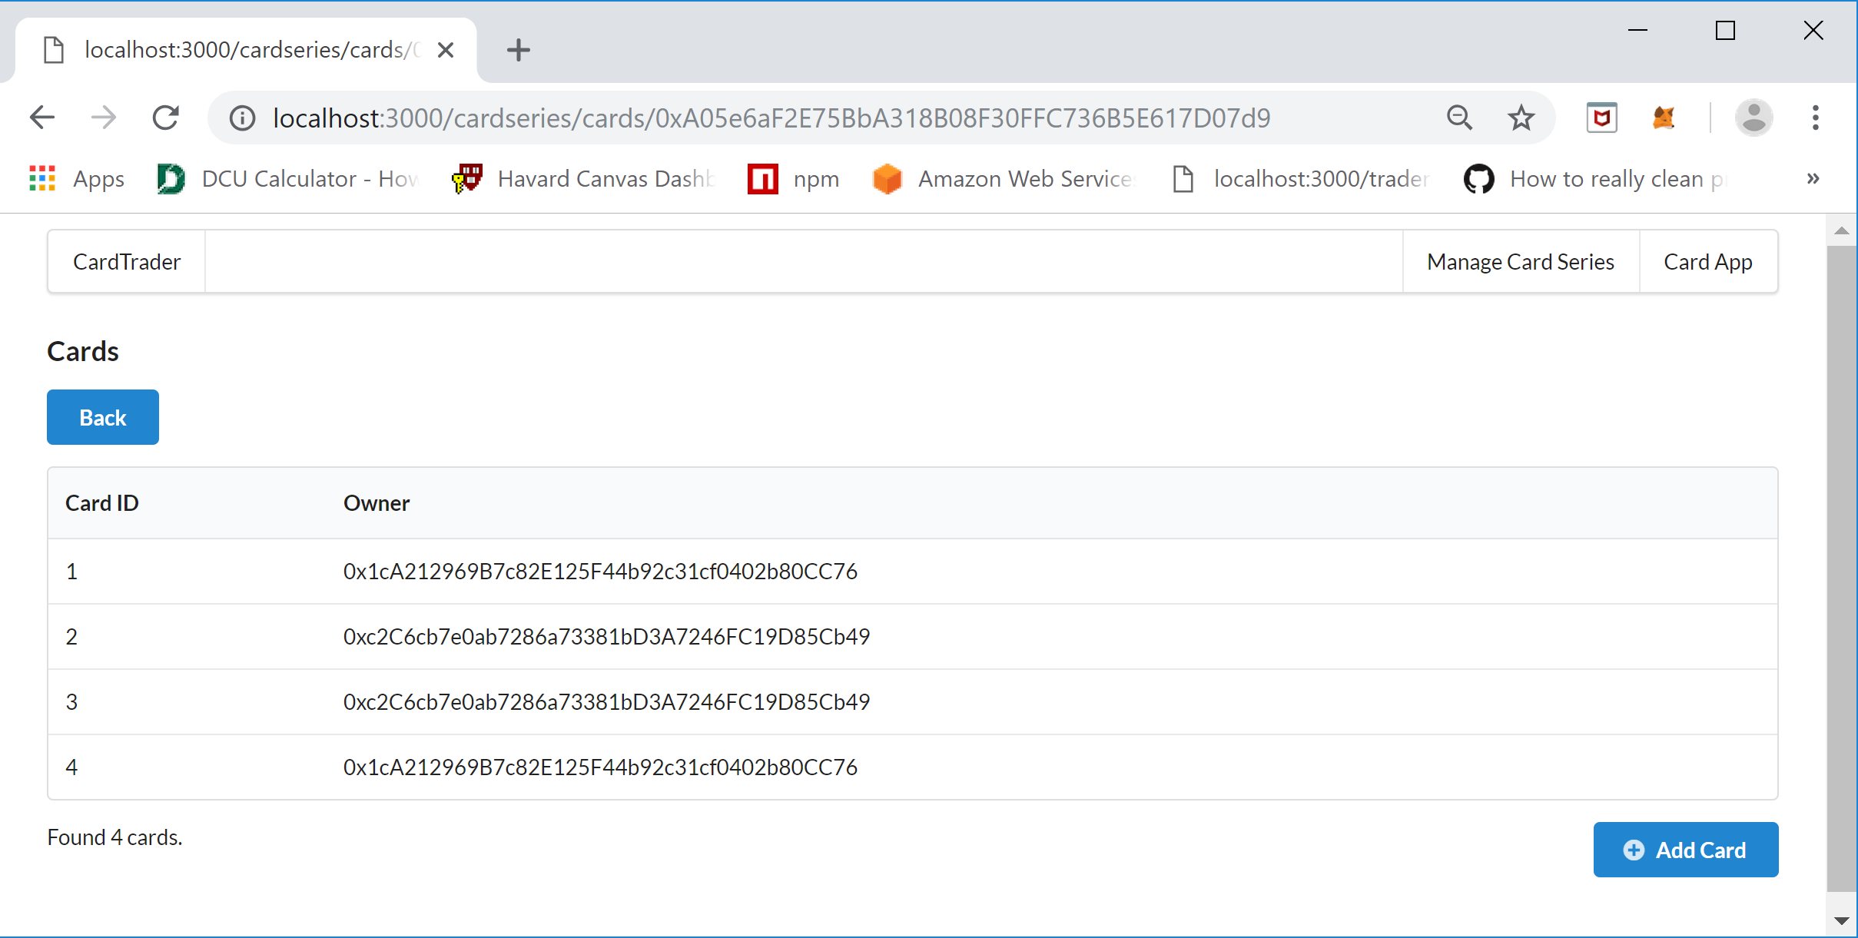

/cardtrader/cardseries/newCard.js – Page for adding new Trading Cards for the selected Card Series

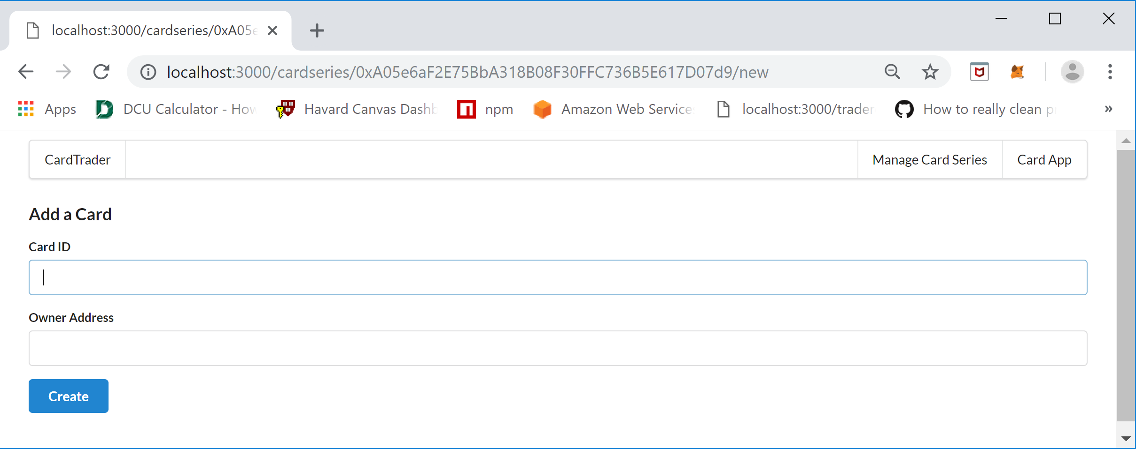

/cardtrader/cardseries/traderequests.js - Page that lists all the Trade Requests for the selected Card Series

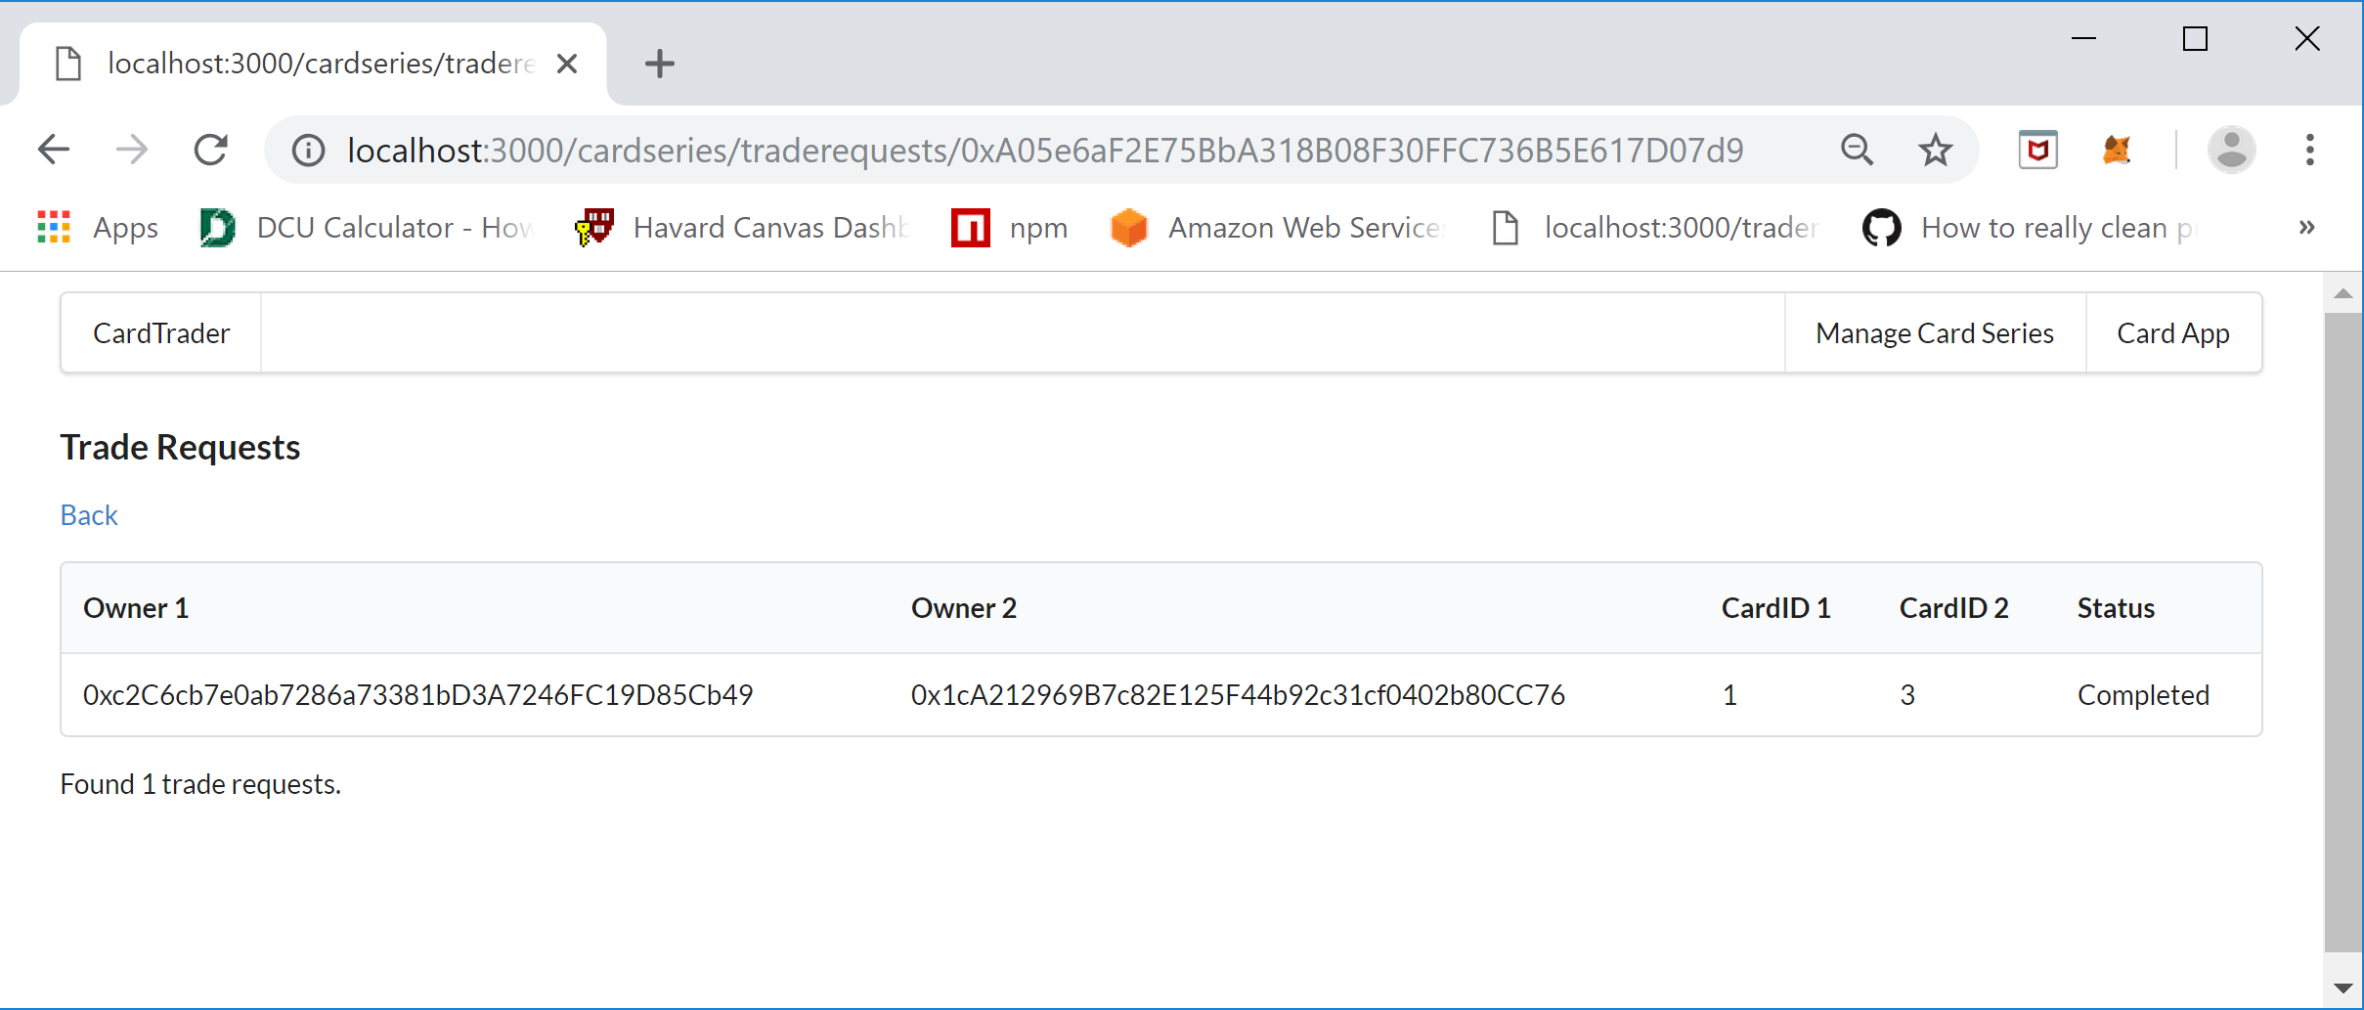

The pages that are used for the “Card App” functionality is in the /cardtrader/trader directory.

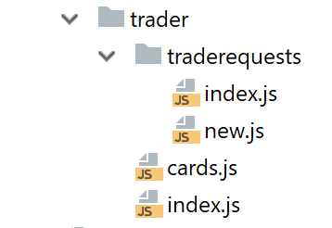

The following are the names of the pages and the rendered web pages they relate to:

/cardtrader/trader/index.js – Page that shows the Card Series that have Trading Cards owned by the currently selected MetaMask Wallet Account. The page displays the “View Card Series” link to drill into a specific Card Series to see cards owned, view/approve/decline trade requests, and trade cards by creating new Trading Request.

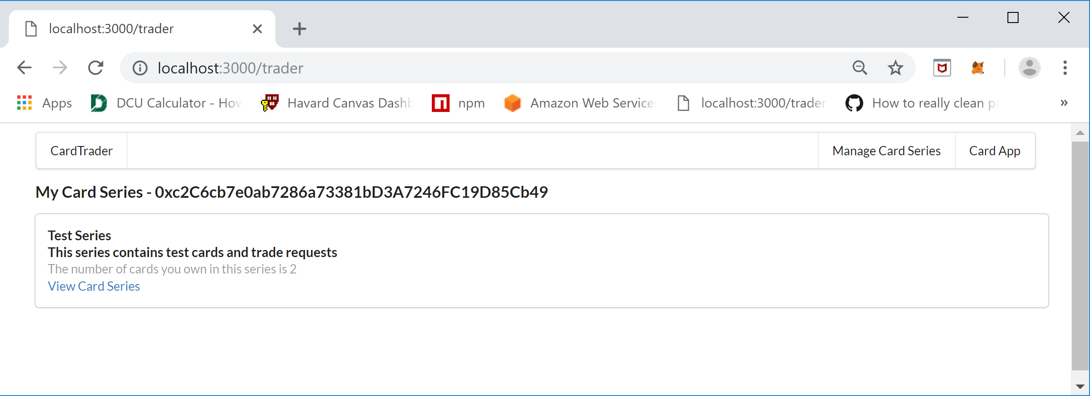

/cardtrader/trader/cards.js – Page that shows the cards owned by the current account.

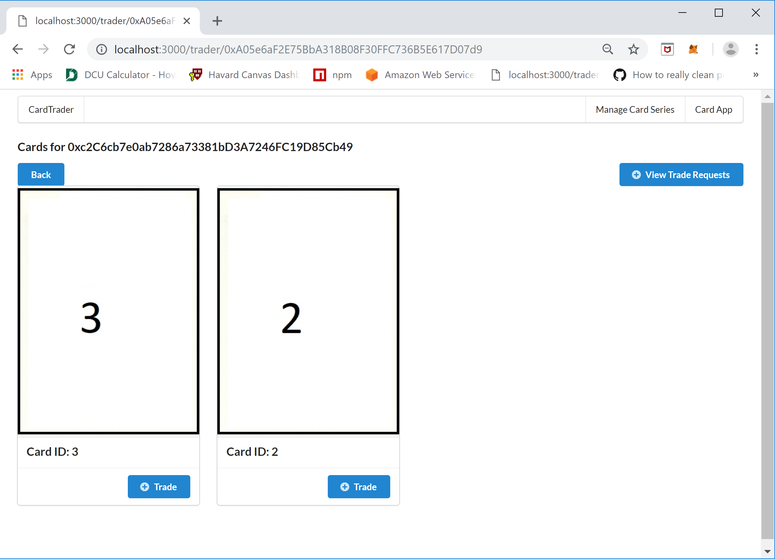

/cardtrader/trader/traderequests/new.js – Page that allows the user to select a card to trade for. The page will only display cards that are not already owned by the current account, the card to trade for is actually a carousel control and will show an arrow bar when the cursor floats over the edges to see more cards to choose from or move backwards to see cards already viewed.

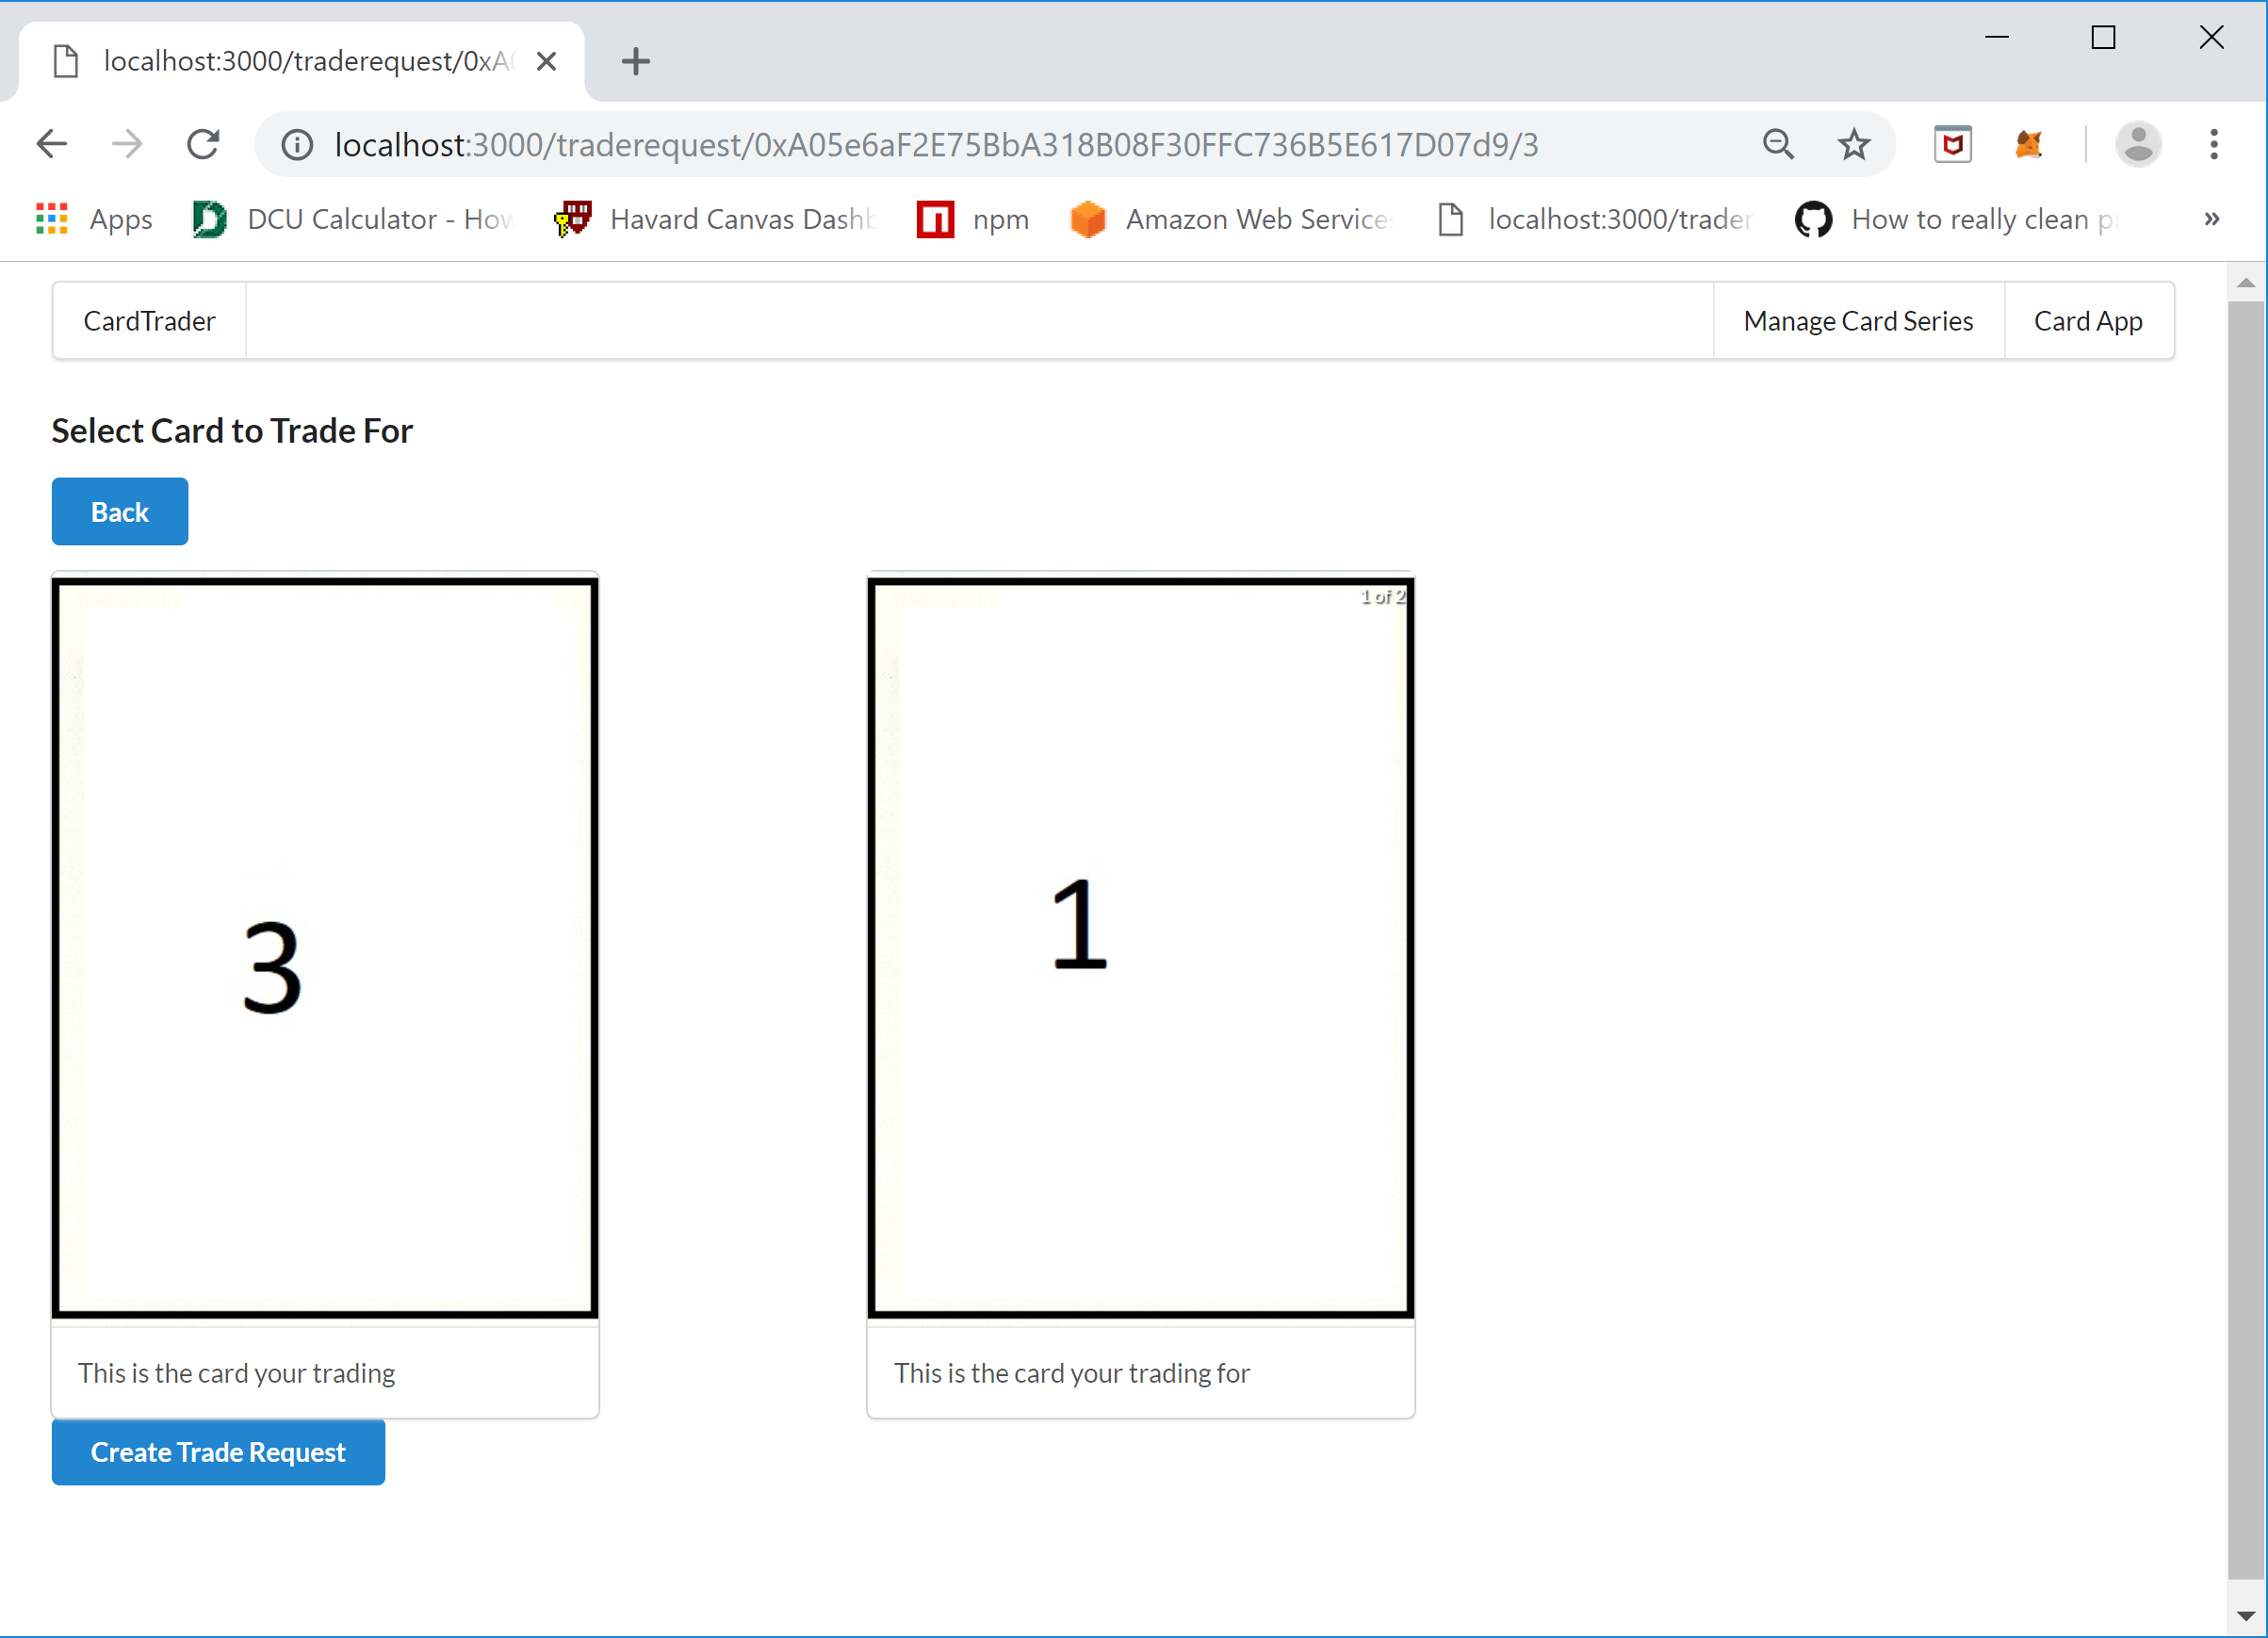

/cardtrader/trader/traderequests/index.js – Page that lists all the Trade Requests along with the status of the request, this page also will display two buttons, Approve and Decline, if he current account is the Requestee for the Trade Request.

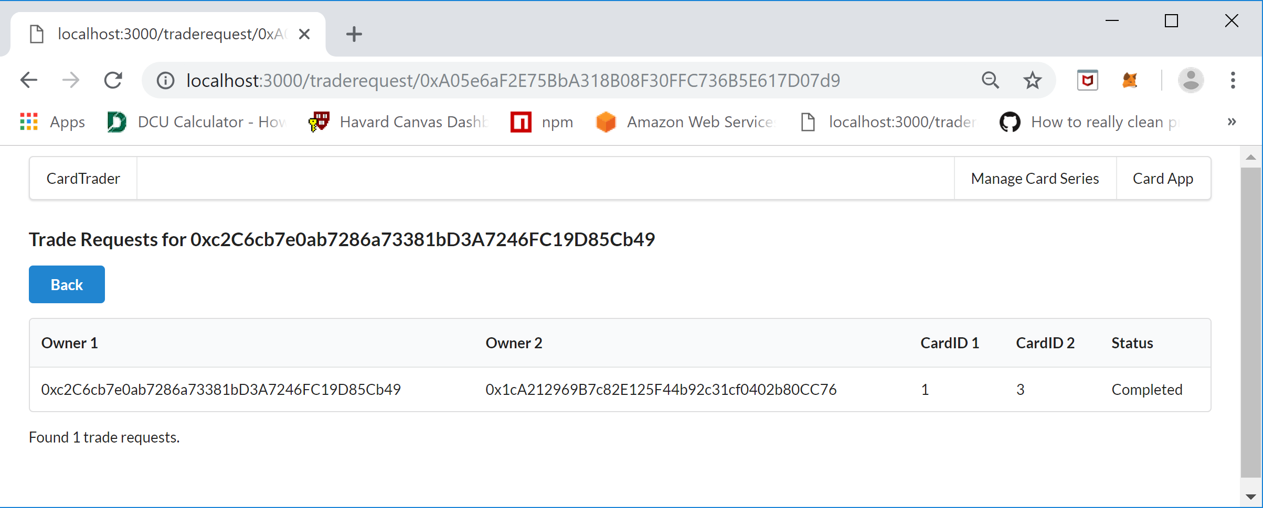

### Components

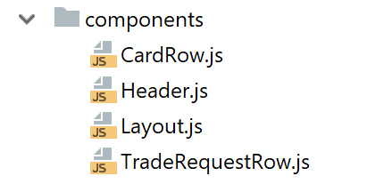

There several re-usable components used in the CardTrader application. The CardRow.js component is used in “Manage Card Series” functionality as part of the /cardtrader/cardseries/cards.js page to render the list of cards contained in a Card Series. The Header.js component is used to create the menu at the top of every page. The Layout.js component is used as a template page that displays the header and then renders every other page within itself. The TradeRequestRow.js component is used in “Manage Card Series” functionality as part of the /cardtrader/cardseries/traderequests.js page to render each Trader Request contained within a Card Series contract in a Table, this component is NOT used for the “Card App” Trade Request pages.

### Ethereum

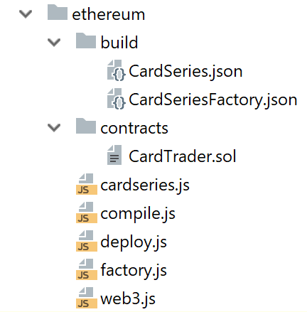

The Ethereum directory contains the contract code, scripts to compile and deploy the contracts (CardSeriesFactory, CardSeries), and helper classes to work with the card factory and card series functionality of the contract within the application. The build directory contains the contract ABI interfaces for the Card Series in the CardSeries.json file and the Card Series Factory in the CardSeriesFactory.json file. These files are generated by running the /Ethereum/compile.js script using the “node compile.js” command which compiles the solidity code in the /etherum/contracts/CardTrader.sol Solidity file using the solc compiler. To deploy the CardSeriesFactory contract the /ethereum/deploy.js script is run using the “node deploy.js” script. Once the contract is deployed the script will print the address for the newly deployed CardSeriesFactory contract, it is important to copy and save this address as it will need to be added to the factory.js script in order to create and return a CardSeriesFactory contract JavaScript object to make calls to the methods to the deployed CardSeriesFactory contract.

### Factory.js File

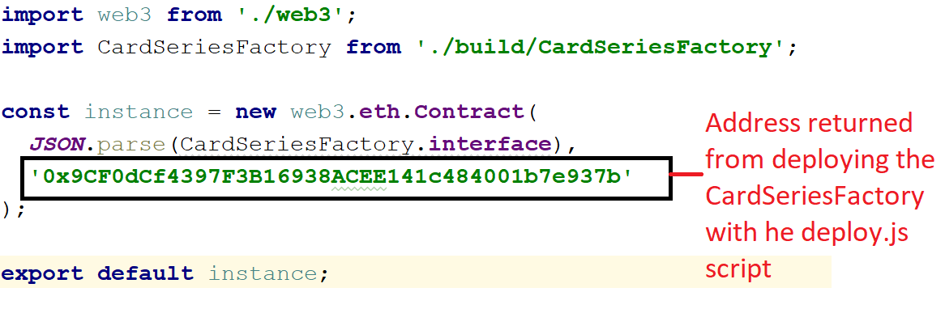

The /ethereum/cardseries.js file is a helper class that creates and returns a CardSeries JavaScript object given a Card Series address that is stored within the Card Series Factory. The CardSeries object returned is used to make calls against the deployed CardSeries contract using JavaScript. The last and most important file is the web3.js file which creates and returns a web3 object to make JavaScript contract requests using the correct provider. The web3.js file uses the MetMask plug-in as a provider for the client side and it uses whatever is on the server for server-side request, however, note that all calls used in the CardTrader application actually are client side only and always use the MetaMask provider. The following line of code was added to request access approval by the end user to connect to their MetaMask Wallet which is a new security feature in MetaMask:

**window.web3.currentProvider.enable();**

### Static files

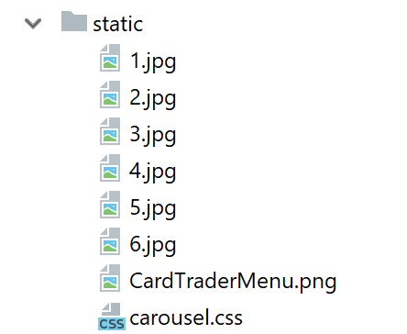

The jpg image of the cards within the card series are stored in the static folder, in a real production application these would be stored in a content delivery network (CDN), a centralized database or files server, or possibly the Inter-Planetary File System. For the sake of simplicity for this Proof-of-Concept application the image files are stored locally on the client. The stylesheet that is used by the image carousel control is also stored in this directory in the carousel.css file. An image of the Card Trader application is also stored here to show on the homepage which has a brief description of the application and the functionality that can be accessed using each menu item.

### Mocha Tests

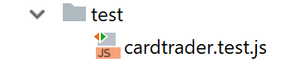

Mocha tests to test the Card Series Factory and Card Series contract functionality are stored in this directory in the cardtrader.test.js file. There is a helper script within the package.json file that makes it easy to run the scripts by simply typing “npm run test” which will run all the tests in this directory using the Mocha testing framework. If you run the tests you should see the following output:

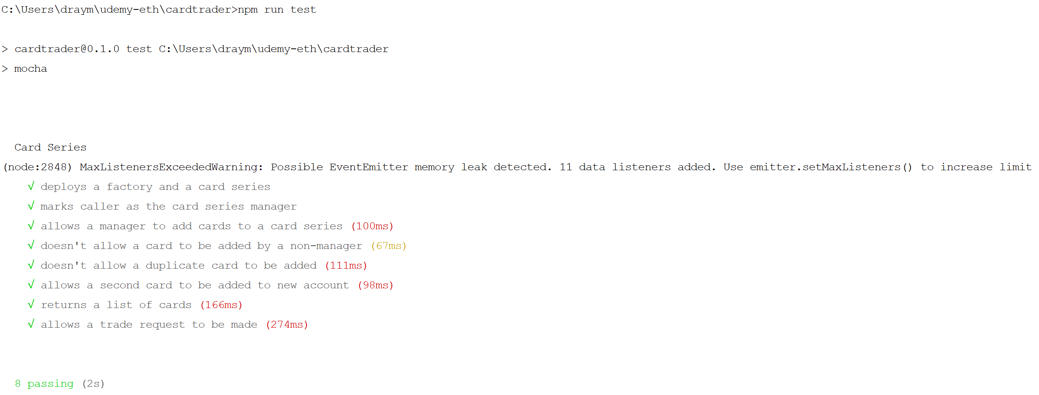

### Routes, Web Server, Package.json, and Reademe

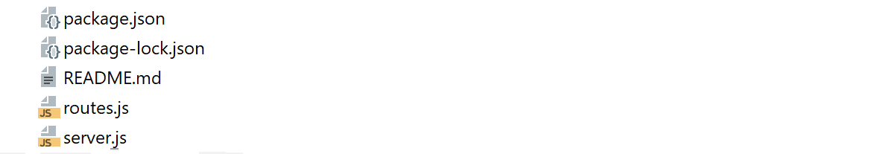

The package,json file has helper scripts to run the development server and the mocha scripts, it also stored a list of all the npm packages used within the application. The README.md file contains a quickstart guide for the Card Trader application. The routes.js file is used within the application to map routing strings to pages, the following routes are listed in this file:

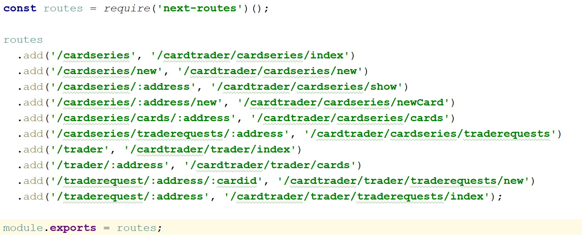

The server.js file creates a simple web server on port 3000 to host the application on a server that users can use to run to run the Card Trader client JavaScript in their Chrome browser. In a production deployment the CardTrader DApp would be turned into a native application using a program like PhoneGap so that the program could be installed on a mobile device and not rely on the web server.

## The Last Mile

It is assumed that trading cards are generally all pre-created for a given series and/or a given year. So, as an example you may see traditional printed cards like Baseball Greats of 2018, or Pokémon Earth and Moon Series 1 etc. The cards are then printed packaged and sent to stores in the traditional model. For the card trader blockchain all the trading cards for a given series are created and associated with a new Card Series Contract. The cards are purchased either online with traditional money or using cryptocurrency from the distributor or directly from the manufacturer. The user will enter their wallet address at the time of purchase and the trading cards will then be provisioned by the manager of the Card Series contract for that user. No new cards will be created after all cards have been released and provisioned for a given series and the card id’s will be a hash of the card itself, which will included meta-data that makes the card unique, and signed by the manufacturer’s private key so that it can be verified to be authentic (might use HMAC hashing to generate card id). The contract and application will also use access control to ensure that only specific addresses can execute sensitive functions, the contract’s access control will only allow a manufacturer user to create and add cards to the contract. No other entity will be able to generate new and valid card id’s and there will be a fixed number of cards manufactured for any series of trading cards. The cards are all virtual entities that are not connected to a physical card in the “real” world so there is no need for trusted third party such as an Oracle Service, although that would an excellent feature for a purely open-source version to trade physical cards.

**For the Card Trader POC the last mile protections such as a card id that is a hash of the card image and meta-data was not implemented as this would make testing the application much more time consuming and difficult and require a significant amount of coding. However, for a production version of the Card Trader application securing the card and making them difficult or impossible to forge would be a requirement. Also, the POC is not properly secured yet and that would also be a requirement for a production version of the application. One important piece of the Last Mile and securing the Card Trader application was implemented and that was integration into the client-side MetaMask Wallet as a provider. Also, the contract has some access control implemented so that only managers of the Card Series Contract, which is the account address that was used to create it through the Card Series Factory, can add new trading cards to the contract and blockchain.**

## Appendix I – Solidity Contract Code

pragma solidity ^0.4.25;

// Card Series Factory is used by trading

// card manufacturers to create card series

// the stores a specific collection of trading

// cards. A manufacturer may create many different

// card series over time.

contract CardSeriesFactory {

// variable to store a list of card series

// contracts address created by this factory

address[] private _deployedCardSeries;

// variable to store a list of card series

// contracts series id created by this factory

mapping (uint => bool) private _deployedCardSeriesID;

// Factory function to create card series contracts

function createCardSeries(uint seriesID, string seriesName,

string seriesDescription) public {

require(!_deployedCardSeriesID[seriesID]);

address newCardSeries = new CardSeries(seriesID, seriesName,

seriesDescription, msg.sender);

_deployedCardSeries.push(newCardSeries);

}

// Function to return a list of card series contract

// addresses created and reference by this factory

function getDeployedCardSeries() public view returns(address[]) {

return _deployedCardSeries;

}

}

// Card Series contracts are contracts that

// store cards and trade requests. A manager

// will add cards to a card series contract

// and associate an owner upon creation.

// Owners can create trade requests to

// trade any of their cards for another

// card.

contract CardSeries {

// Trade Request have 4 possible status, if

// the request is approved the status will

// be Completed after the transaction

enum TradeStatus { AwaitingApproval, Approved, Declined, Completed }

// TradeRequest structure holds the state

// to suppor the trade request workflow.

// owner1 is the owner requesting the TradeRequest

// owner2 is the owner of the card owner1 wants to trade for

// cardID1 is the card id of owner1's card

// cardID2 is the card id of owner2's card

// status status/stage of the trade request

struct TradeRequest{

address owner1;

address owner2;

uint cardID1;

uint cardID2;

TradeStatus status;

}

// structure to Store all the trade request keys

// to support retrieving keys for a given owner

struct TradeRequestKeys{

bytes32[] keys;

uint keyCount;

}

//mapping of key to the trade request

//this variable is public in order to

//return a TradeRequest structure

//which is not supported for functions

mapping (bytes32 => TradeRequest) public tradeRequestsByKey;

//mapping of key to the trade request

mapping (address => TradeRequestKeys) private _tradeRequestsByOwner;

// Array of al trade requests in this series

bytes32[] private _tradeRequests;

//array of unique card id's

uint[] private _cards;

//mapping of unique card id's

mapping (uint => bool) private _cardsByCardID;

//mapping of card id's to owner

mapping (uint => address) private _ownedCardsByCardID;

//mapping of owner to all cards owned by them

mapping (address => uint[]) private _cardsOwnedByAddress;

//address of the manager of the contract

address public manager;

//a series id that identifies the card

//campaign which all cards in this contract

//are part of and can be externally linked

uint private _seriesID;

//Series Name is a human readable and

//meaningful name for this series

string private _seriesName;

//A description of the series

string private _seriesDescription;

//Modifier to restrict some functions to the manager

modifier restricted() {

require(msg.sender == manager);

_;

}

// Constructor used to create a new card series

constructor(uint seriesID, string seriesName,

string seriesDescription, address creator) public {

manager = creator;

_seriesID = seriesID;

_seriesName = seriesName;

_seriesDescription = seriesDescription;

}

// Function to create a trade request given the cards

// to be traded, the caller must be the owner of card 1

function createTradeRequest(uint cardID1, uint cardID2)

public returns (bytes32) {

// check that the owner of the card is also he caller

require(msg.sender == getCardOwnerByCardID(cardID1));

address owner1 = msg.sender;

address owner2 = getCardOwnerByCardID(cardID2);

// check that the trade request is for a card

// no already owner by the caller

require(owner1 != owner2);

uint keyCount = _tradeRequests.length;

// create a unique trade request key

bytes32 key = keccak256(abi.encodePacked(owner1, cardID1, owner2, cardID2, keyCount));

// creae a new trade request and iniialize with validated values

TradeRequest memory newTradeRequest = TradeRequest({

owner1: owner1,

owner2: owner2,

cardID1: cardID1,

cardID2: cardID2,

status: TradeStatus.AwaitingApproval

});

// add trade request to all lists

tradeRequestsByKey[key] = newTradeRequest;

_tradeRequestsByOwner[owner1].keys.push(key);

_tradeRequestsByOwner[owner1].keyCount++;

_tradeRequestsByOwner[owner2].keys.push(key);

_tradeRequestsByOwner[owner2].keyCount++;

_tradeRequests.push(key);

return key;

}

// Function to approve a trade request given the

// trader request key, the approver must be the

// owner of card 2, this also completes the

// trade by swapping the owners of the cards

function approveTradeRequest(bytes32 key) public {

TradeRequest storage tradeRequest = tradeRequestsByKey[key];

address owner = msg.sender;

// check that the owner of card 2 is the caller

require(tradeRequest.owner2 == owner);

tradeRequest.status = TradeStatus.Approved;

completeTrade(tradeRequest);

}

// Function to decline a trade request given the

// trade request key, the caller must be an owner

// of one of the cards and status must not be

// Completed to protect trade requests that have

// already been complete from being marked declined

function declineTradeRequest(bytes32 key) public {

TradeRequest storage tradeRequest = tradeRequestsByKey[key];

address owner = msg.sender;

require(tradeRequest.status != TradeStatus.Completed);

require((tradeRequest.owner2 == owner) ||

(tradeRequest.owner1 == owner));

tradeRequest.status = TradeStatus.Declined;

}

// Function that swaps the cards for an approved trade

function completeTrade(TradeRequest storage tradeRequest) private returns (bool) {

_ownedCardsByCardID[tradeRequest.cardID1] = tradeRequest.owner2;

_ownedCardsByCardID[tradeRequest.cardID2] = tradeRequest.owner1;

uint i = 0;

uint[] storage owner1Cards = _cardsOwnedByAddress[tradeRequest.owner1];

for(i = 0; i < owner1Cards.length; i++){

if (owner1Cards[i] == tradeRequest.cardID1)

{

owner1Cards[i] = tradeRequest.cardID2;

break;

}

}

uint[] storage owner2Cards = _cardsOwnedByAddress[tradeRequest.owner2];

for(i = 0; i < owner2Cards.length; i++){

if (owner2Cards[i] == tradeRequest.cardID2)

{

owner2Cards[i] = tradeRequest.cardID1;

break;

}

}

tradeRequest.status = TradeStatus.Completed ;

}

// Function that is called by the manager of the card series

// contract to add new cards to the contract and assign them

// to owners of the cards, cannot add a card that has

// already been added by card id

function addCard(uint cardID, address owner) restricted public {

// check that the manager is no adding a duplicate card

require(!_cardsByCardID[cardID]);

_ownedCardsByCardID[cardID] = owner;

_cardsByCardID[cardID]=true;

_cardsOwnedByAddress[owner].push(cardID);

_cards.push(cardID);

}

// Function to return the trader request associated with an owner

function getTradeRequestsByOwner(address ownerID) public view returns (bytes32[]) {

return _tradeRequestsByOwner[ownerID].keys;

}

// Function to return all trade request keys associated with this card series contract

function getAllTradeRequests() public view returns (bytes32[]) {

return _tradeRequests;

}

// Function to return all cards id's associated with this card series contract

function getAllCards() public view returns (uint[]) {

return _cards;

}

// Function to return all cards ids associated a specific owner

function getCardsByOwner(address ownerID) public view returns (uint[]) {

return _cardsOwnedByAddress[ownerID];

}

// Function to return the owner of a card given a specific card id

function getCardOwnerByCardID(uint cardID) public view returns (address) {

return _ownedCardsByCardID[cardID];

}

// Function to return the series name

function getSeriesName() public view returns (string) {

return _seriesName;

}

// Function to return a summary of the card series contract

function getSummary() public view returns (uint, string, string, uint, uint, address) {

return(

_seriesID,

_seriesName,

_seriesDescription,

_cards.length,

_tradeRequests.length,

manager

);

}

}

## Appendix II - Trade Request Workflow Diagram

